

|  |  |  |  |  |
| --- | --- | --- | --- | --- |
| 72 Central Campus Dr Salt Lake City, UT 84112 |  |  |  | fluorender@sci.utah.edu  www.fluorender.com |

FluoRender User’s Guide

Version 2.17/August 2015

Table of Contents

[List of Figures 5](#_Toc428439122)

[Chapter 1 What’s New in Version 2.17 7](#_Toc428439123)

[Chapter 2 Installation 9](#_Toc428439124)

[Install FluoRender on Microsoft Windows](#_Toc428439125)

[Install FluoRender on Mac OS X](#_Toc428439126)

[Chapter 3 FluoRender User Interface 14](#_Toc428439127)

[FluoRender on Windows](#_Toc428439128)

[FluoRender on Mac OS X](#_Toc428439129)

[Reorganizing FluoRender’s User Interface](#_Toc428439130)

[Chapter 4 Loading Data 17](#_Toc428439131)

[Volume Data](#_Toc428439132)

[Mesh Data](#_Toc428439133)

[Chapter 5 Managing Data Sets 21](#_Toc428439134)

[Chapter 6 Managing Workspace 23](#_Toc428439135)

[Toolbar Icons](#_Toc428439136)

[Context Menu Commands](#_Toc428439137)

[Chapter 7 Basic Render View Operations 26](#_Toc428439138)

[Multi-view Management](#_Toc428439139)

[Interactions](#_Toc428439140)

[Channel Intermixing Methods](#_Toc428439141)

[Render View Settings](#_Toc428439142)

[Capturing Render View](#_Toc428439143)

[Chapter 8 Adjusting Volume Properties 31](#_Toc428439144)

[Transfer Function Settings](#_Toc428439145)

[Effect Settings](#_Toc428439146)

[MIP Render Mode](#_Toc428439147)

[Quality Settings](#_Toc428439148)

[Other Settings](#_Toc428439149)

[Chapter 9 Output Adjustment 35](#_Toc428439150)

[Chapter 10 Clipping Volumes 36](#_Toc428439151)

[Clipping Plane Translations](#_Toc428439152)

[Clipping Plane Rotations](#_Toc428439153)

[Chapter 11 Adjusting Mesh Properties 38](#_Toc428439154)

[Basic Mesh Properties](#_Toc428439155)

[Mesh Manipulations](#_Toc428439156)

[Chapter 12 Movie Playback and Export 40](#_Toc428439157)

[Basic Movie Operations](#_Toc428439158)

[Advanced Key Frame Movies](#_Toc428439159)

[Automatic Key Generation](#_Toc428439160)

[Frame Cropping](#_Toc428439161)

[Batch Processing (4D Scripts)](#_Toc428439162)

[Chapter 13 Managing Projects 48](#_Toc428439163)

[Chapter 14 Paint Selection 50](#_Toc428439164)

[Brush Types](#_Toc428439165)

[Brush History](#_Toc428439166)

[Selection Settings](#_Toc428439167)

[Brush Properties](#_Toc428439168)

[Creating New Channels from Selection](#_Toc428439169)

[Chapter 15 Measurement 54](#_Toc428439170)

[Ruler Types](#_Toc428439171)

[Profiling](#_Toc428439172)

[Making Changes to Measurement Tools](#_Toc428439173)

[Chapter 16 Component Analysis and Calculations 58](#_Toc428439174)

[Component Analysis](#_Toc428439175)

[Noise Reduction](#_Toc428439176)

[Volume Channel Calculations](#_Toc428439177)

[Colocalization Analysis](#_Toc428439178)

[Chapter 17 Components and Tracking 63](#_Toc428439179)

[Track Map Generation and Management](#_Toc428439180)

[Component Selection Settings](#_Toc428439181)

[Ghost Settings](#_Toc428439182)

[ID Lists](#_Toc428439183)

[Output](#_Toc428439184)

[Chapter 18 Volume-Mesh Conversion 67](#_Toc428439185)

[Chapter 19 Contributing to FluoRender 68](#_Toc428439186)

[Developing and Contributing with Source Code via GitHub](#_Toc428439187)

[OpenCL Kernel Editor](#_Toc428439188)

[Chapter 20 Settings 71](#_Toc428439189)

[Project Settings](#_Toc428439190)

[Rendering Settings](#_Toc428439191)

[Performance Settings](#_Toc428439192)

[File Format Settings](#_Toc428439193)

[Settings through the “fluorender.set” File](#_Toc428439194)

[Appendices 78](#_Toc428439195)

[A. Functions of FluoRender](#_Toc428439196)

[B. File Formats](#_Toc428439197)

[C. Keyboard Shortcuts](#_Toc428439198)

[Index 86](#_Toc428439199)

# List of Figures

[Figure 2‑1. Installation language. 9](#_Toc428439200)

[Figure 2‑2. Setup welcome box. 10](#_Toc428439201)

[Figure 2‑3. License agreement. 10](#_Toc428439202)

[Figure 2‑4. Destination location. 11](#_Toc428439203)

[Figure 2‑5. Main user interface of FluoRender on Windows. 11](#_Toc428439204)

[Figure 2‑6. Additional tasks. 12](#_Toc428439205)

[Figure 2‑7. Ready to install. 12](#_Toc428439206)

[Figure 2‑8. FluoRender DMG image on Mac OSX. 13](#_Toc428439207)

[Figure 3‑1. Main user interface of FluoRender on Windows. 14](#_Toc428439208)

[Figure 3‑2. Main user interface of FluoRender on Mac OSX. 15](#_Toc428439209)

[Figure 4‑1. Load a Z-stack sequence. 18](#_Toc428439210)

[Figure 4‑2. Load a time sequence. 19](#_Toc428439211)

[Figure 5‑1. Dataset panel. 21](#_Toc428439212)

[Figure 6‑1. Workspace panel. 23](#_Toc428439213)

[Figure 7‑1. Multiple render views in FluoRender. 26](#_Toc428439214)

[Figure 7‑2. Channel intermixing modes. 29](#_Toc428439215)

[Figure 8‑1. Volume properties. 31](#_Toc428439216)

[Figure 9‑1. Output adjustment panel. 35](https://d.docs.live.net/6a73dd1f17cfc8cb/FluoRender/Manual_217_Aug-15.docx#_Toc428439217)

[Figure 10‑1. Clipping plane panel. 36](https://d.docs.live.net/6a73dd1f17cfc8cb/FluoRender/Manual_217_Aug-15.docx#_Toc428439218)

[Figure 11‑1. Mesh properties. 38](#_Toc428439219)

[Figure 11‑2. Mesh manipulations. 39](#_Toc428439220)

[Figure 12‑1. Main movie playback controls. 40](#_Toc428439221)

[Figure 12‑2. Save or export a movie or time sequence. 41](#_Toc428439222)

[Figure 12‑3. Basic movie playback controls. 42](#_Toc428439223)

[Figure 12‑4. Advanced movie playback controls. 43](#_Toc428439224)

[Figure 12‑5. Auto key options. 44](#_Toc428439225)

[Figure 12‑6. Frame cropping controls. 45](#_Toc428439226)

[Figure 13‑1. Save project dialog. 48](#_Toc428439227)

[Figure 14‑1. The selection part of the Analyze dialog. 50](#_Toc428439228)

[Figure 15‑1. Launch Measurement window from main toolbar. 54](#_Toc428439229)

[Figure 15‑2. Measurement window. 54](#_Toc428439230)

[Figure 16‑1. Component analysis and calculation functions in the Analyze window. 58](#_Toc428439231)

[Figure 16‑2. Noise reduction dialog. 60](#_Toc428439232)

[Figure 16‑3. Colocalization analysis dialog. 61](#_Toc428439233)

[Figure 17‑1. Components and Tracking window. 63](#_Toc428439234)

[Figure 17‑2. Ghosts of a tracked cell. 65](#_Toc428439235)

[Figure 18‑1. Convert dialog. 67](#_Toc428439236)

[Figure 19‑1. OpenCL kernel editor. 69](#_Toc428439237)

[Figure 20‑1. Settings, project panel. 71](#_Toc428439238)

[Figure 20‑2. Settings, rendering panel. 72](#_Toc428439239)

[Figure 20‑3. Settings, performance panel. 73](#_Toc428439240)

[Figure 20‑4. Settings, file format panel. 74](#_Toc428439241)

# What’s New in Version 2.17

Thank you for using FluoRender and spending some time on the operation manual. You may also want to read the documentation of tutorials, which can be downloaded from FluoRender’s website.

FluoRender Version 2.17 fixed several issues of reading files and using the paint brush tool in streaming mode.

New features and improvements include:

|  |  |
| --- | --- |
|  | **History for paint brush operations** |

New in the 2.17 release of FluoRender, you can let FluoRender remember a certain number of steps in the history of paint brush operations. Then, these operations can be undone or redone. See Chapter 14 for more details.

|  |  |
| --- | --- |
|  | **A secondary color setting for volume data** |

New in the 2.17 release of FluoRender, you can select a secondary color to highlight paint brush selected structures within a volume. Previously, this color is calculated according to the primary color of the volume. See Chapter 8 for more details.

|  |  |
| --- | --- |
|  | **Choice of color maps and color map modes** |

New in the 2.17 release of FluoRender, you can choose among several color maps in addition to the rainbow color map in the previous versions. Also, you can map the colors to X, Y, or Z coordinate values of a volume, in addition to intensity values. See Chapter 8 for more details.

|  |  |
| --- | --- |
|  | **Protractor tool** |

New in the 2.17 release of FluoRender, you can use a protractor tool to measure angles. See Chapter 15 for more details.

|  |  |
| --- | --- |
|  | **Separation of non-overlapping samples into channels** |

New in the 2.17 release of FluoRender, when you load a Prairie/Bruker XML file of multiple tiles, the tiles are separated into channels if there is no overlapping among the tiles. See Chapter 4 for more details.

|  |  |
| --- | --- |
|  | **Recording channel intermixing modes** |

New in the 2.17 release of FluoRender, changes to the channel intermixing modes are recorded in an animated movie. See Chapter 12 for more details.

|  |  |
| --- | --- |
|  | **Baking clipping planes** |

New in the 2.17 release of FluoRender, when you bake a volume, its clipping plane information is applied. Zero values are padded in the space clipped. See Chapter 5 for more details.

|  |  |
| --- | --- |
|  | **A new 4D script type for executing an external application from FluoRender** |

New in the 2.17 release of FluoRender, a new 4D script type is added to allow execution of an external application during 4D playback. The external application can be used to apply processing on each time point of the time sequence. We also include a sample application under the Windows operating system. The sample application processes a volume file and labels individual structures. It can be used jointly with the new tracking functions. See Chapter 12 and Chapter 17 for more details.

|  |  |
| --- | --- |
|  | **Automatic tracking** |

New in the 2.17 release of FluoRender, you can track multiple moving structures simultaneously in a time sequence. See Chapter 17 for more details.

# Installation

## Install FluoRender on Microsoft Windows

|  |  |
| --- | --- |
|  | We have discontinued the support of 32-bit Windows since Version 2.14. Please make sure that your hardware is 64-bit compatible and a 64-bit Windows is installed. If you have any questions about Windows version, please contact us. Continued support will only be available for the latest Release of FluoRender. |

1. Download *FluoRender\_2.17.0\_win64.exe* from our website (https://github.com/SCIInstitute/fluorender/releases).
2. Double-click the installer icon to initiate the installation.

|  |  |
| --- | --- |
|  | You may be asked by “User Account Control” to provide permission to allow the installer from an unknown publisher to make changes to your computer. Click “Yes” to allow FluoRender to install. |

1. The first dialog you will see will ask you to select your language for installation. Click OK.

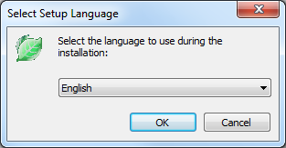

Figure ‑. Installation language.

1. At this point, the installer checks to see if you have FluoRender already on your machine. If FluoRender is not yet on your machine, continue to step 5. If the version you are installing already exists, setup will terminate.

|  |  |
| --- | --- |
|  | If you wish to re-install the same version of FluoRender, first uninstall using Add/Remove programs in the Control Panel. |

If you are trying to install an older version of FluoRender, you will be asked to confirm an installation overwrite of the newer version. If your existing FluoRender is older than what is being installed, you will be asked if you wish to upgrade to the installer’s version.

1. Welcome to FluoRender setup. Click Next to continue.

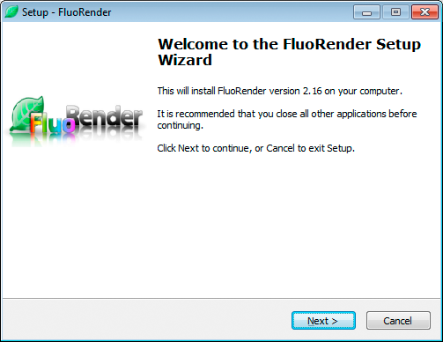

Figure ‑. Setup welcome box.

1. License Agreement. FluoRender is under the MIT license agreement. Please read and accept the license. Click Next to continue.

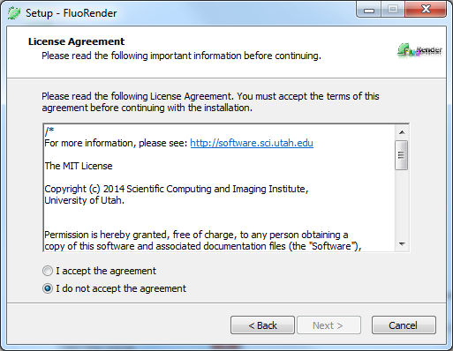

Figure ‑. License agreement.

1. Choose your installation path. Default is recommended. Click Next to continue.

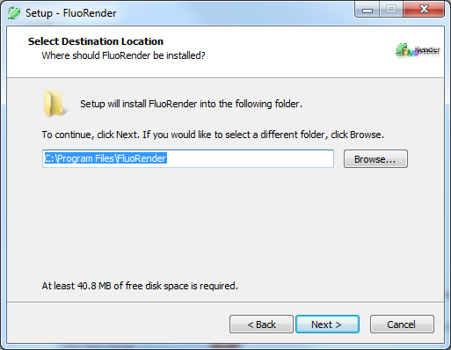

Figure ‑. Destination location.

1. Select shortcut options. Click Next to continue.

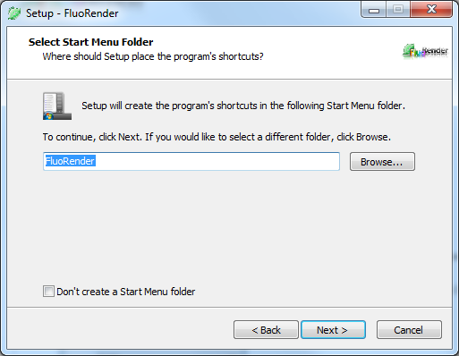

Figure ‑. Main user interface of FluoRender on Windows.

1. Select Additional Tasks. Check the box if you wish to have a desktop shortcut to FluoRender. Click Next to continue.

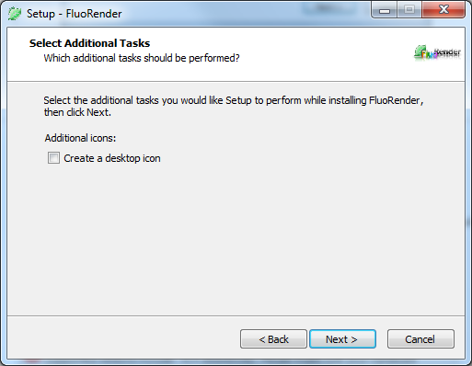

Figure ‑. Additional tasks.

1. Ready to Install. Here is a review of what will be installed on your machine. Click Install to continue.

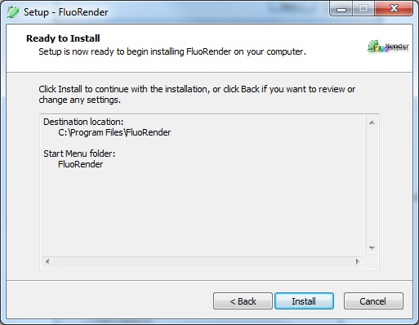

Figure ‑. Ready to install.

|  |  |
| --- | --- |
|  | You may also be asked to install “Microsoft Visual Studio 10 Runtime Redistributable for x64”. You will need an internet connection for the installer to download and install this requirement for FluoRender. |

1. After clicking “Install”, setup will copy files onto your computer. When completed, setup will tell you that install is complete and to click “OK” to run FluoRender.

## Install FluoRender on Mac OS X

|  |  |
| --- | --- |
|  | We have discontinued the support of old Mac OS X versions. Currently supported versions include: 10.9 (Mavericks). Please make sure your hardware is compatible with this version of Mac OS X. If you are unable to use OS X 10.9, you will need to use FluoRender 2.14 (also on FluoRender’s download website). FluoRender 2.14 is compatible with OS X 10.6 and above. There are many new features and bug fixes that are not included in 2.14. Continued support will only be available for the latest Release of FluoRender. |

1. Download *FluoRender\_2.17.0\_osx.dmg* from our website (https://github.com/SCIInstitute/fluorender/releases).
2. Double-click the disk image file icon to open the image and view it in Finder.

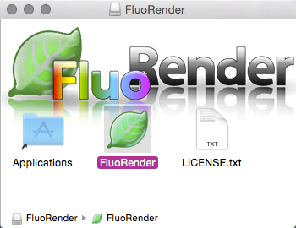

Figure ‑. FluoRender DMG image on Mac OSX.

1. Please open the LICENSE.txt and be sure you agree to the terms of the license.
2. Select the FluoRender file icon, and drag and drop it onto the “Applications” shortcut. You may have to grant permission by entering your computer password.
3. FluoRender is now on your machine. You can access it in your launcher or Applications shortcuts.

# FluoRender User Interface

|  |  |
| --- | --- |
|  | Not every function of FluoRender is available for Mac OS X. Use the Windows release for advanced functions including paint selection. Refer to appendix for the difference of FluoRender on the two operating systems. The rest of this guide is based on the Windows version of FluoRender. |

## FluoRender on Windows

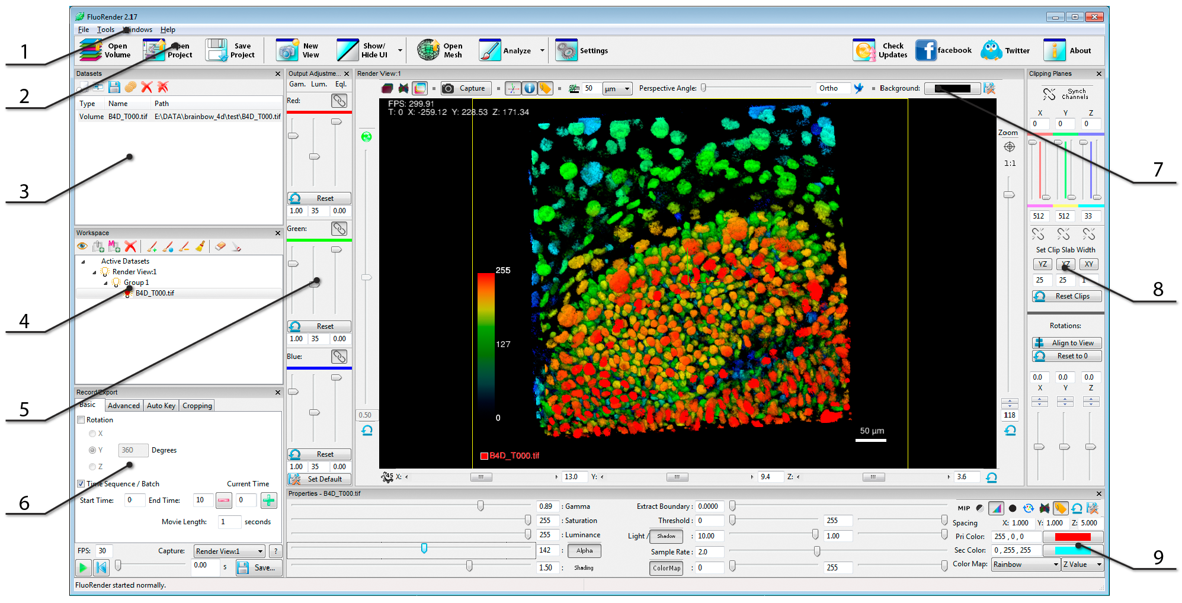

Figure ‑. Main user interface of FluoRender on Windows.

1. **Main menu.** Functions in main menu can be accessed from the main toolbar as well.
2. **Main tools.** The most commonly used functions are listed on the left side of the main toolbar, including loading volumes and projects.
3. **Dataset panel.** Currently loaded data sets are listed in the dataset panel. They can be added to a render view. Multiple instances of the same data set can be added to render views as well.
4. **Workspace panel.** Currently visualized data sets are listed in the workspace panel. For volume data, each item is called a “channel”. There is no limit to the number of channels can be visualized. When a channel is selected in the workspace panel, most subsequent operations are applied to the selection.
5. **Output adjustment panel.** Use this panel to adjust the visual settings of render view output, as individual RGB color channels. When a volume is selected in the workspace, its adjustments are for the entire group that the selection belongs; when a render view is selected, its adjustments are for the entire render view.
6. **Record/Export panel.** Record and export a rotation movie, a time sequence, or a key frame animation using this panel. The selected view port can also be cropped for export.
7. **Render view panel.** The main panel for visualization and analysis. Multiple render view panels are supported.
8. **Clipping plane panel.** Use clipping planes to isolate a portion of selected volume. Clipping planes belonging to different channels can also be synchronized.
9. **Property panel.** All adjustable visual settings of current selection. Adjustments are applied in real-time.

## FluoRender on Mac OS X

|  |  |
| --- | --- |
|  | Although the OS X interface is nearly identical to Windows (minus unsupported functions), the appearance is slightly different due to intrinsic Operating System differences. The “look and feel” more represents that of a Mac. |

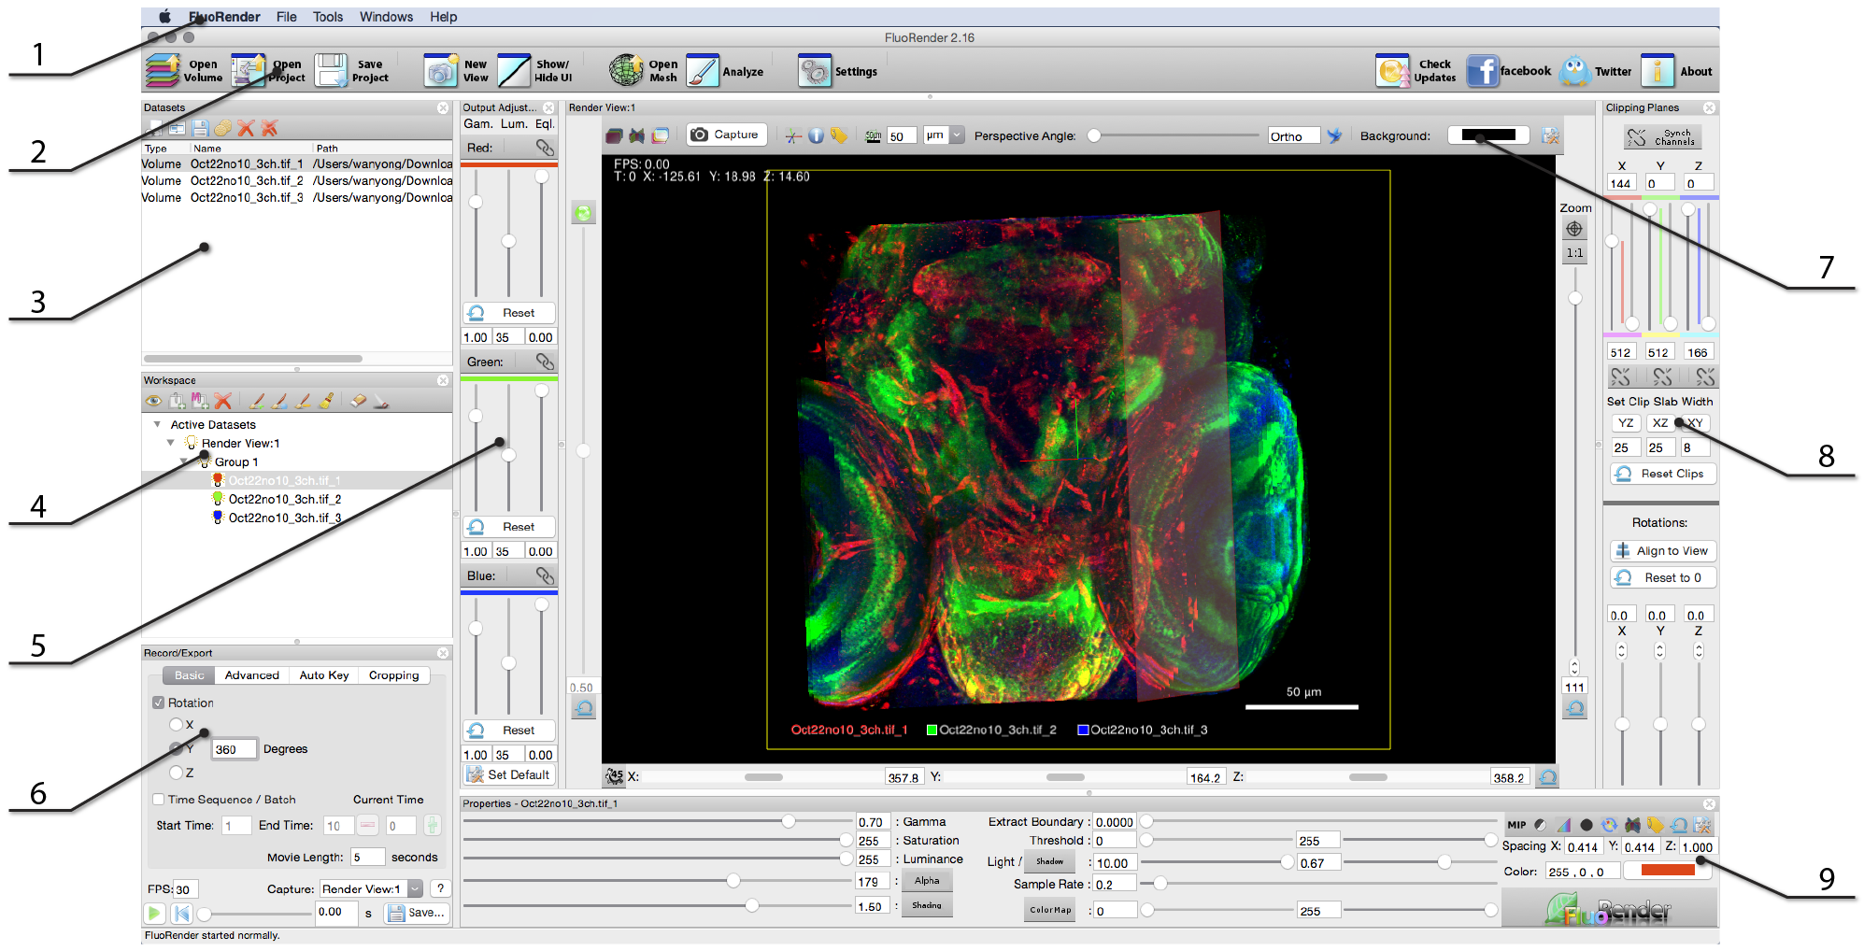

Figure ‑. Main user interface of FluoRender on Mac OSX.

1. **Main menu.** Functions in main menu can be accessed from the main toolbar as well.
2. **Main tools.** The most commonly used functions are listed on the left side of the main toolbar, including loading volumes and projects. You will notice a difference here on a Mac, as the drop-down menu is not available to the Analyze button. You can access those features through the main menu, under Tools.
3. **Dataset panel.** Currently loaded data sets are listed in the dataset panel. They can be added to a render view. Multiple instances of the same data set can be added to render views as well.
4. **Workspace panel.** Currently visualized data sets are listed in the workspace panel. For volume data, each item is called a “channel”. There is no limit to the number of channels can be visualized. When a channel is selected in the workspace panel, most subsequent operations are applied to the selection.
5. **Output adjustment panel.** Use this panel to adjust the visual settings of render view output, as individual RGB color channels. When a volume is selected in the workspace, its adjustments are for the entire group that the selection belongs; when a render view is selected, its adjustments are for the entire render view.
6. **Record/Export panel.** Record and export a rotation movie, a time sequence, or a key frame animation using this panel. The selected view port can also be cropped for export.
7. **Render view panel.** The main panel for visualization and analysis. Multiple render view panels are supported.
8. **Clipping plane panel.** Use clipping planes to isolate a portion of selected volume. Clipping planes belonging to different channels can also be synchronized.
9. **Property panel.** All adjustable visual settings of current selection. Adjustments are applied in real-time.

## Reorganizing FluoRender’s User Interface

Most panels, dialogs, and windows of FluoRender can be closed by clicking the close button on the top right corner. To reopen a panel, use the Windows menu. You can also hide or show all panels except render views using the “Show/Hide UI” button in the main toolbar. Most panels can be repositioned by dragging its top bar. Additionally, panels can be resized by dragging the dividers between two panels.

# Loading Data

Volume and mesh objects are the two major data types to be visualized and analyzed in FluoRender. A volume is a 3D image comprised of sample points on a regular 3D grid, each sample point called a voxel. A volume can be saved on disk as a single file, or as a series of 2D images. A time sequence of volumes is generated from continuously scanning a living sample. A time sequence can be saved as individual time points, or as a single file with a supported format. See Appendices for more details on file formats.

## Volume Data

### Single channel

To open a single channel volume, click “Open Volume”  in the main toolbar. In the file browser dialog, choose a supported volume data file. Then, click “Open”. The selected file is loaded into FluoRender and visualized in the render view with default settings.

### Multiple channels

To open more than one channel of volumes, click “Open Volume”  in the main toolbar. In the file browser dialog, select multiple files within the same file folder. Then, click “Open”. The selected files are loaded into FluoRender and visualized in the render view with default settings. The first three channels loaded are assigned with red, green, and blue colors respectively. Then, a subsequently loaded channel is assigned with a randomly generated color.

|  |  |
| --- | --- |
|  | Alternatively, the “Open Volume” command can be found in the main menu. Users can also drag and drop file(s) to the FluoRender main user interface to open them. If FluoRender is not currently running, Users can drag and drop file(s) to the desktop icon of FluoRender. FluoRender also supports file names as command inputs. For example, to launch FluoRender with opened files, type the following command in the console window: FluoRender.exe “file1” “file2”. |
|  | If excitation wavelength information is read from meta data, colors can be automatically assigned. See Chapter 20 and the appendix on file format for more details. |

### Z-stack sequence

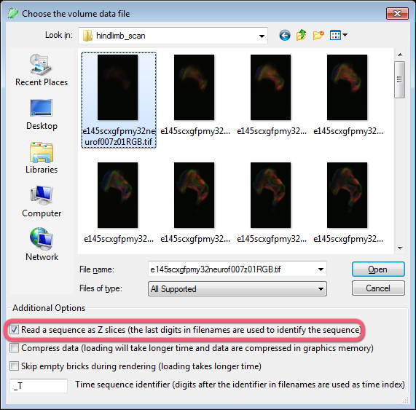

Figure ‑. Load a Z-stack sequence.

A volume channel stored in the form of a series of 2D images (Z-stacks) can be loaded with FluoRender, on condition that the stack files are named properly with numbers to index the sequence. To open a Z-stack sequence, click “Open Volume”  in the main toolbar. In the file browser dialog, make sure “Read a sequence as Z slices” (Figure 4‑1) is checked. Then, select **just one** file from the sequence and open it. FluoRender will match the file names within the folder to the selected file and load the entire sequence as a volume channel.

|  |  |
| --- | --- |
|  | FluoRender is using the numeric value appeared last in the selected file name to index the sequence. For example, a selected file’s name is e145scx32neuro007z01RGB.tif. The last appeared numeric value is 01. FluoRender will search for all files within the folder having a name pattern of e145scx32neuro007z\*\*RGB.tif. Then, FluoRender uses their individual numeric values to order them. If there is a problem of reading a Z-stack sequence, first check if the file names are correctly numbered. |

### Time sequence

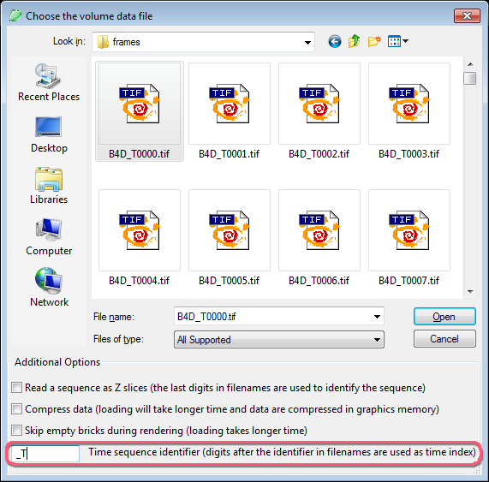

Figure ‑. Load a time sequence.

FluoRender can also load a time sequence. Similar to a Z-stack sequence, a time sequence has to be named correctly for loading. However, there is a configurable identifier for a time sequence. To open a time sequence, click “Open Volume”  in the main toolbar. In the file browser dialog, make sure the “Time sequence identifier” matches that within the sequence. Then, select **just one** file in the sequence to open it. The selected file is visualized. To view the time sequence, use the playback functions in the “Record/Export” panel (Chapter 12).

|  |  |
| --- | --- |
|  | Make sure the time sequence identifier only appears once in the file name. For example, when using identifier “\_T”, a file name pattern like “My\_Time\_Sequence\_T\*\*.tif” can confuse FluoRender, because “\_T” appears twice. In this case, you can simply change the identifier in the file browser dialog to “e\_T”, which appears only once in the file name. |

### Large Data Streaming

If a data set is large in terms of spatial resolution or channel number, rendering can become less interactive, or even impossible. Enable large data streaming when data size exceeds graphics memory size. Details of large data streaming can be found in Chapter 20.

|  |  |
| --- | --- |
|  | Skip empty bricks during rendering can be enabled when volumes are loaded for large data streaming. When enabled, each brick is checked and empty bricks are ignored during rendering to allow faster speed. |

### File Formats

To achieve great performance, we code our own readers for different formats, instead of using third-party format converters. See Appendices for supported file formats.

### Automatic Channel Separation

When loading Prairie/Bruker XML format, if the data set contains tiles scanned at different stage locations, FluoRender will check if the tiles overlap with each other. If no overlapping tiles are found, FluoRender separates each tile into a channel. This is useful when an experiment scans several samples mounted on the same stage. Make sure you set the stage to leave some space between any two samples.

## Mesh Data

To load mesh data, click “Open Mesh”  in the main toolbar. In the file browser dialog, choose one or multiple mesh files to load them.

|  |  |
| --- | --- |
|  | Only Wavefront OBJ format is currently supported. A mesh object can have associated materials and textures. |

# Managing Data Sets

Loaded data sets are listed in the “Datasets” panel (Figure 5‑1).

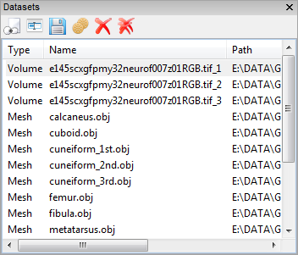

Figure ‑. Dataset panel.

Each loaded data set has a type identifier (volume, mesh, etc.), a name (initialized to its file name), and a path. For a data set created within FluoRender, the path entry is empty initially. When a created data set is saved, the path entry is updated. Only one data set can be selected from the list at one time. The following operations are applied to the selected data set.

 **Add.** It adds selected data set to the render view. If multiple render views are opened, the data set is added to the first render view in the “Workspace” panel.

|  |  |
| --- | --- |
|  | Alternatively, user can right-click a data set. In the context menu, under “Add”, there is a list of currently opened render views. A different render view than the first one can be selected through the context menu. The same data set can be added to a render view for multiple times. Each instance of the data set has its own volume settings. However, if the intensity values of any one of the instances are changed, all will be updated. |

** Rename.** It allows renaming selected data set. Names are used to uniquely identify data sets within FluoRender. They are initialized to their file names after loading, which can be changed for easy data organization. FluoRender will automatically resolve name conflicts, for example, when data sets are duplicated.

** Save.** It saves selected data set to hard drive. FluoRender will always ask for a directory and file name for saving a data set. Make sure that important original data sets are not over-written.

|  |  |
| --- | --- |
|  | The file formats that a selected volume can be saved are less than that can be read. For example, for volumes, TIFF is the preferred format. |

** Bake.** It saves selected volume data set with its properties applied. For example, you can set a threshold value for a volume data set to cut off noise signals. When you “bake” the volume data set, you save it with the threshold applied, therefore removing the noise signals. Volume properties that are saved with the baking function include:

* Gamma
* Saturation
* Alpha
* Extract boundary
* Threshold (Soft threshold, see Chapter 20)
* Clipping planes

|  |  |
| --- | --- |
|  | Data values outside of the clipping planes are set to 0 when baked. You may use this feature to create a sub volume from the original data. However, the actual data size is unchanged. Clipped space is padded with zero values. |

** Delete.** It deletes selected data set from FluoRender. It does not delete data from hard drive.

In addition, the “delete all” **** command is used to delete all data sets in the list.

# Managing Workspace

Only data sets in the “Workspace” panel can be visualized and analyzed (Figure 6‑1). Most operations in FluoRender are applied on currently selected item in the “Workspace” panel. Only one item can be selected at one time. If a volume or mesh is selected, its properties are loaded into the “Property” panel. Items are organized into a “Render View”-“Group”-“Data Set” hierarchy. Items can be reorganized through dragging and dropping them on the list.

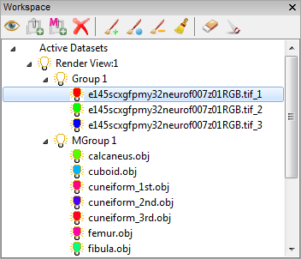

Figure ‑. Workspace panel.

## Toolbar Icons

 **Toggle visibility.** Click to enable and disable the visibility of a selected data set. The same effect can be achieved by double-clicking the icon of a data set. Visibility of a group or a render view can be toggled similarly. When the visibility of a group is disabled, every item within the group becomes invisible.

 **Add a volume group.** Volume data sets are organized under groups. Some operations are applied on groups, instead of individual volume channels, including output adjustments, and synchronized operations.

|  |  |
| --- | --- |
|  | Alternatively, a volume data set can be dragged to the bottom empty space within the “Workspace” list. A new volume group is automatically created. |

** Add a mesh group.** Mesh groups are for organizing mesh data sets.

** Delete selection.** It removes a selected data set from the workspace. Removed data sets are not deleted from FluoRender and can still be accessed from the “Dataset” panel.

The rest of the workspace toolbar icons are for paint selection. Please refer to Chapter 14 for details.

## Context Menu Commands

|  |  |
| --- | --- |
|  | Context menu commands can vary when different items are selected. |

### Common context menu commands

**Toggle Visibility.** It changes the visibility of a selected item.

**Add Volume Group.** It adds a volume group to current render view.

**Add Mesh Group.** It adds a mesh group to current render view.

**Delete.** It deletes current selection from workspace. “Close” is shown instead for a render view.

**Randomize Colors.** It randomly chooses a color for current selection.

|  |  |
| --- | --- |
|  | Alternatively, you can hold down the “Ctrl” key and double-click the icon of an item to randomize its color. |

### Context menu commands for render views and groups

**Collapse/Expand.** It collapses or expands a list of child items.

### Context menu commands for volumes

**Isolate.** It disables the visibility of all other data sets except current selection.

**Show All.** It enables the visibility of all data sets.

**Analyze.** It shows the “Analyze” window (see Chapter 14 and Chapter 16).

**Noise Reduction.** It shows the “Noise Reduction” window (see Chapter 16).

**Counting and Volume.** It shows the “Counting and Volume” window (see Chapter 16).

**Colocalization analysis.** It shows the “Colocalization Analysis” window (see Chapter 16).

**Measurement.** It shows the “Measurement” window (see Chapter 15).

|  |  |
| --- | --- |
|  | Details on volume processing and analysis functions are discussed in the respective chapters. |

### Context menu commands for mesh objects

**Manipulate.** It shows mesh transformation controls in the “Property” panel. Selected mesh object can be rotated, translated, and scaled (see Chapter 11).

# Basic Render View Operations

Render views are the most important panel/window in FluoRender. Data are visualized and analyzed within render views. Multiple render views can be created and managed. Figure 7‑1 shows FluoRender’s capability to mimic a classical “four-view” configuration. However, each render view provides powerful visualization functions, so it is adequate to use single render view for most visualization and analysis requirements.

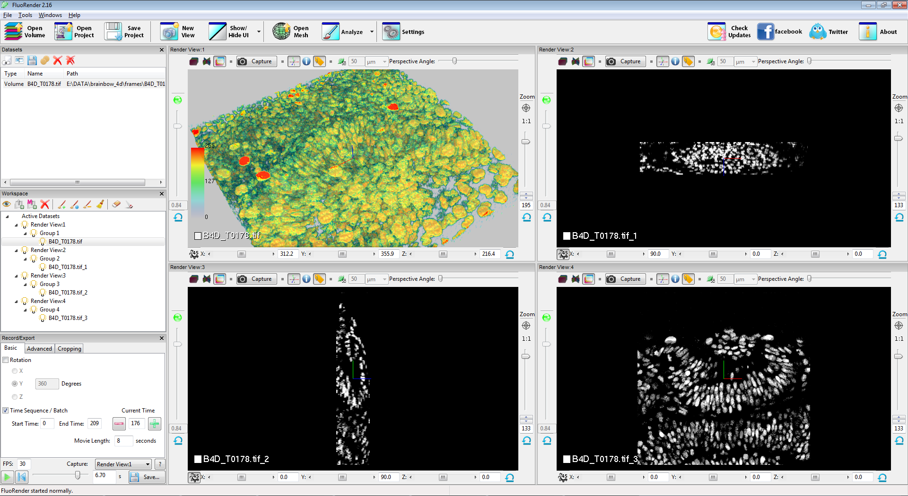

Figure ‑. Multiple render views in FluoRender.

## Multi-view Management

Render views are sequentially numbered in a session. FluoRender requires at least one render view available at the center of the main user interface. To create a new render view panel, click “New View”  in the main toolbar. The newly created render view is placed side-by-side with the initially created one. To adjust the sizes of render views, drag the divider between two render views. Like most panels in FluoRender, additional render views can be detached from the main user interface and become a standalone window. This can be useful when multiple monitors are available. Additional render views can be closed from the “Workspace” panel. However, the initial render view cannot be closed or detached from the main user interface. To close an additional render view, right-click its icon in the “Workspace” panel. In the context menu, choose “Close”.

Opened data sets are automatically added to the initial render view. To add a data set to an additional render view, right-click the data set in the “Dataset” panel. In the context menu, choose “Add to”, and then choose the desired render view. Data sets are duplicated by instance, which means that they share original data values, but can receive different settings. For example, there are four instances of the opened data set in Figure 7‑1. The instance in the top-left render view is color-mapped, while the rest are not.

## Interactions

Basic render view interactions can be achieved using a mouse or compatible pointing device. In addition, standard control widgets can be found surrounding a render view panel.

|  |  |
| --- | --- |
|  | Free-fly  mode should be disabled for trackball-like interactions. When free-fly mode is enabled, the following interactions use a different model. See free-fly mode for more details. |

### Rotations

To rotate the view, click and hold down the left mouse button (or primary button), and drag mouse to the intended direction. Additional controls for rotation are located at the bottom of the render view panel. Use the sliders to restrict rotations around a single axis. Or, you can input the exact rotation values. The sliders are working similarly to “jog” or “shuttle” dials. The handles are located at the center of the sliders. A rotation angle around an axis starts to change when user drags the handle to one direction. The change rate depends on the offset of the handle to its center. The view keeps rotating at the specified speed as long as the handle is held at an offset position. This allows users to continuously rotate the view without resorting to the movie export functions.

There are two buttons for rotation control.

 **Geared rotation.** When enabled, all rotation angles are restricted to multipliers of 45. This allows users to quickly rotate to axis-aligned angles. For example, the axis-aligned views in Figure 7‑1 use this function to visualize image sections.

 **Reset rotation.** It sets all rotation angles of X, Y, Z axes to 0.

|  |  |
| --- | --- |
|  | Rotations of different render views can be synchronized by enabling “Link all render views’ rotations” in the “Rendering” panel of the setting dialog. |

### Zooming

To zoom the view, click and hold down the right mouse button (or secondary button), and drag mouse in straight up-down or left-right directions.

**Zooming in:** Up or right.

**Zooming out:** Down or left.

Additional controls for zooming are located on the right border of the render view. Use the slider to change the zoom level. Or, input an exact zoom level value. Value input also allows zoom levels greater than the slider’s range.

There are two buttons for zooming control.

1:1 **1:1 ratio.** It sets a zoom level so that one sample point (pixel or voxel) of the original data occupies exactly one screen pixel.

|  |  |
| --- | --- |
|  | 100 zoom level does not necessarily mean 1:1 ratio, and vice versa. We use the relative size of the entire data boundary versus render view size to determine the zoom level. So, when visualizing a square data set in a square render view, the data set occupies the entire render view when the zoom level = $\sqrt{2}×100≅141$. 100 zoom level usually means that the entire data set can be seen with generous margins. |

 **Reset zooming.** Resets the zoom level to default. The default zoom level is saved when render view settings are saved.

### Panning

To pan the view, click and hold down the middle mouse button (or wheel), and drag mouse to the intended direction. If middle button is not available, hold down the “Ctrl” key (or “Command” key on a Mac) and use the left mouse button instead.

Panning can be reset using a button  (Center data) on the right border of the render view.

|  |  |
| --- | --- |
|  | Use the center axis as an indicator for the center of the render view. You can turn on the center axis with the button C:\Users\HP2\SkyDrive\FluoRender\center_axis.png on the top border of render view. |

### Perspective Angle

Perspective angle determines how 3D structures are projected. Strong foreshortening effect is achieved with large angle values. Use the slider on the top border of render view to set a perspective angle. When the slider handle is placed to the left end, orthographic projection is used. When the mouse cursor is moved into the slider region, a bounding box of currently selected volume channel is displayed.

|  |  |
| --- | --- |
|  | When the “free-fly”  mode is enabled, the projection is forced to perspective. |

### Selecting

Both volume and mesh data sets can be selected directly from the render view. Click on the visualization of a data set with the left mouse button, and the selected data set is highlighted in the “Workspace” panel.

## Channel Intermixing Methods

For multi-channel data, FluoRender provides three intermixing modes (Figure 7‑2). Use different intermixing modes to best visualize features from different channels.



Figure ‑. Channel intermixing modes.

 **Layered.** Channels are rendered individually and then layered one on top of another. Top channels in the workspace are also rendered on top. Changing the order of channels in the workspace will affect the visualization result. Layered mode is good for visualizing un-occluded features from top channels.

 **Depth.** Channels are intermixed with correct spatial occlusion. Depth mode is good for inspecting spatial relationships between channels.

 **Composite.** Channels are rendered individually and then their colors are summed up. Composite mode is good for occluded features between colocalized structures.

|  |  |
| --- | --- |
|  | A different render mode can be set for a group. Refer to Chapter 8 for more details. |
|  | Use output adjustments of a render view to reduce brightness if outputs of composite mode become oversaturated. See Chapter 9 for more details. |

## Render View Settings

The following render view settings are available through control widgets surrounding render view.

** Center view axis.** It toggles the display of center view axis. The center of render view is indicated by a widget of color-coded lines, perpendicular to each other. It rotates with current rotations settings.

 **Information.** It toggles information display. Information includes render speed (in frames per second), and current cursor location in 3D.

** Legend.** It displays a legend of currently visualized data.

** Scale bar.** It displays a scale bar at the bottom margin of render view. The length that the scale bar measures can be set using the numeric input next to the scale bar button. This button can be clicked twice to enable the scale bar text. A unit can be chosen from the dropdown list next to the numeric input. Click thrice to disable the scale bar.

|  |  |
| --- | --- |
|  | If correct metadata are read from data, the unit of the scale bar is chosen automatically. If no metadata can be obtained, the unit defaults to µm. |

 **Free-fly.** When free-fly mode is enabled, it allows user to rotate the view around the viewing point, instead of the center of render view, which is the default interaction mode of render view that uses a trackball/turn-table model. Projection mode is set to perspective. Zooming operations become moving camera forward/backward.

**Background color.** It changes background color of render view. To view data of low intensities, a background with a bright color can be helpful.

|  |  |
| --- | --- |
|  | A gradient background can be enabled in the FluoRender settings. When a gradient background is enabled, a faded color of the chosen background color is used at the “horizon” of render view. |

** Depth attenuation.** It attenuates the renderings of data into a dark color based on their distance to the viewer. The strength of depth attenuation can be adjusted using the slider on the left border of render view.

** Save settings.** It saves all render view settings into a file. The settings are restored to the saved values next time when FluoRender is launched.

## Capturing Render View

Click the “Capture” button to save the render view as an image file. In the pop-up dialog, input the desired file name for the captured image.

# Adjusting Volume Properties

When a visible volume channel is selected in the “Workspace” panel, its properties are shown in the “Property” panel (Figure 8‑1).

|  |  |
| --- | --- |
|  | When the visibility of a volume channel is disabled, its properties will not be loaded into the “Property” panel even if it is selected. |



Figure ‑. Volume properties.

## Transfer Function Settings

A transfer function determines how intensity values from the original volume are mapped (or transferred) to colors that can be viewed on screen with the help of rendering techniques.

**Gamma.** It adjusts a nonlinear intensity and transparency mapping of the channel values, using a “Gamma curve”: $V_{out}=V_{in}^{γ}$. Increasing Gamma value maps originally intensity values to brighter colors; decreasing Gamma darkens them. Notice that transparency mapping is also influenced by the Gamma value. Therefore, setting a high Gamma value also makes rendering noisier. Or, it accentuates the low intensity values from the original volume, which usually makes the rendering (an integration calculation) darker. Considering such characteristics of Gamma, the direction of the slider is reversed by design.

**Saturation.** It sets a threshold value that maps to the maximum output, or “saturated” output. All intensity values greater than the setting are mapped to the brightest color. You can decrease this value to enhance low intensity signals, or, when the original scan is dark.

**Luminance.** It changes the luminance of the primary color assigned to the volume. This setting is linked to the primary color setting. An HSV color model is used for luminance calculation.

**Alpha.** A multiplier to transparency mapping. Decreasing this value makes rendering more transparent. Alpha setting can be disabled. When disabled, volume transparency mapping is disabled. All voxels become opaque. It is useful when a thin layer of volume is visualized. For example, the image sections in Figure 7‑1 have Alpha disabled.

**Extract boundary.** It is a threshold value for gradient magnitude. First, the gradient magnitude for each voxel is calculated. Then, voxels with lower gradient magnitude values than the setting are excluded from rendering. Increasing this value extracts salient boundary structures.

**Threshold.** It sets two threshold values (low and high). Voxels of intensity values within the range of setting are rendered. Use this setting to exclude noisy signals.

|  |  |
| --- | --- |
|  | You can set a soft threshold in the settings. Soft thresholds can make edges soft. See Chapter 20 for more details. |

**Primary Color.** It is the base color of the selected volume channel. Color can be set by typing RGB numbers in the text input box, or from the color chooser. Shortcuts to most commonly used colors are also available. Double-click the text input box to first select all text. Then, type the following letter code for different predefined colors.

r – Red; g – Green; b – Blue; c – Cyan; m – Magenta; y – Yellow; w – White, k – Black.

|  |  |
| --- | --- |
|  | A dark color, such as black, can be used for bright background. |
|  | Alternatively, a random color can be assigned from the “Workspace” panel. See Chapter 6 for more details. |
|  | If excitation wavelength information is read from meta data, colors can be automatically assigned. See Chapter 20 and Appendices for more details. |

**Secondary Color.** It is the color to highlight selected structures within a volume. By default, the highlight color is calculated as the inverse of the primary color and changes with it. Once you choose a secondary color, it is fixed to your choice.

**Color map.** When enabled, it maps original intensity values to a color map. The range of the color map can be adjusted using the low and high values. Additionally, you can choose a color map type and mapping mode.

|  |  |  |
| --- | --- | --- |
| **Color Map Type** | | **Mapping Mode** |
| Rainbow |  | Intensity |
| Reverse rainbow |  | Z value |
| Hot |  | Y value |
| Cool | E:\OneDrive\FluoRender\cm04_cool.png | X value |
| Diverging | E:\OneDrive\FluoRender\cm05_div.png |  |

 **Invert.** It inverts original intensity values so that high becomes low, and vice versa.

|  |  |
| --- | --- |
|  | Use inversion when a thick sample is mostly occupied with high intensity signals. Threshold setting can be used in conjunction with inversion to visualize deep structures. |

## Effect Settings

**Shading.** When enabled, it applies shading effect on local features. Higher local contrast can be achieved by lowering this value.

|  |  |
| --- | --- |
|  | Rendering can become too bright when this setting is enabled. In such a case, use “output adjustment” to lower the brightness. See Chapter 9 for more details. |

**Light.** It changes the ratio between highlight and shade.

**Shadow.** When enabled, it applies a shadow effect on rendering. The value setting controls the strength of the shadow effect.

## MIP Render Mode

The maximum intensity projection mode can be enabled to visualize concentrations of high intensity values.

|  |  |
| --- | --- |
|  | When MIP is enabled, certain transfer function settings become unavailable, including luminance, Alpha, extract boundary, and threshold. In addition, MIP cannot be enabled in the Depth channel intermixing mode. Effect settings are available in MIP mode for shape and detail enhancement. |

## Quality Settings

**Sample rate.** It determines the density of slices for rendering one voxel. A higher setting improves rendering quality but slows down interaction speed.

|  |  |
| --- | --- |
|  | Slices are recalculated when viewing direction is changed. It makes sure that slices are always facing the view for little artifact. Therefore, user may experience varying rendering speed for an anisotropic volume. A “Variable sample rate” setting can be enabled to automatically adjust sample rate for both high quality and interactive speed. See Chapter 20 for more details. |
|  | A value higher than the slider’s range can be set using the numeric input. |

 **Interpolation.** When enabled, it uses trilinear interpolation for smooth rendering result. Otherwise, nearest neighbor interpolation is used.

|  |  |
| --- | --- |
|  | It is usually desirable to disable interpolation when a single image section is visualized and exact intensity values are examined. See Chapter 10 for more details on rendering image sections. |

 **Smoothing.** When enabled, a low-pass filter is applied to rendered images to suppress high frequency noise.

|  |  |
| --- | --- |
|  | The filter window size changes with zoom level. The effect of low pass filtering is most obvious at high zoom levels. Therefore, smoothing is usually applied to reduce artifacts when zoomed in, for example, to remove artifact from trilinear interpolation. |

## 

## Other Settings

**Spacing.** It sets the spacing between two sample point in original data, or voxel size, in X, Y, Z directions. It uses the unit in scale bar settings. If metadata are correctly read from a scan, this setting is automatically determined. Otherwise, default values are used.

 **Synchronize group.** Once enabled, settings of current selection are propagated to other channels within the same group. Subsequent setting changes of any channel in the group are also automatically applied to other channels. Group channels of similar scans into one group and set up an initial setting with this function. Disable synchronization for finer adjustment of each channel.

** Depth mode in group.** It forces depth channel intermixing mode within a group, disregarding render view’s settings. Usually, a group in depth mode is layered on top of other channels and visualized without occlusion.

** Show legend.** When enabled, it includes current selection into the render view legend. Legend of render view has to be enabled in order to see it. Exclude channels of low importance from legend to save render view space.

 **Save settings.** It saves all volume property settings into a file. The settings are restored to the saved values when FluoRender is launched.

|  |  |
| --- | --- |
|  | Settings such as color and luminance are determined when a volume is added to render view. Spacing settings can be read from a scan’s metadata. If correct spacing settings are read from metadata, the saved values are not used. |

# Output Adjustment

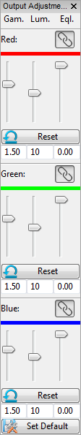Most volume property settings are applied in 3D space before rendering and channel intermixing. To make finer adjustments to rendered and intermixed results in 2D image space, FluoRender provides a set of output adjustments (Figure 9‑1).

Disregarding the number of volume channels to be visualized, the final output has three fixed color channels: red, green, and blue. For each color channel, there are three adjustment settings: Gamma, luminance, and equalization.

Figure ‑. Output adjustment panel.

**Gamma.** It uses a Gamma curve to remap the color intensities. Increasing Gamma brightens the overall result in a nonlinear fashion.

**Luminance.** It is a multiplier that modulates the color intensities. Increasing luminance brightens the result linearly.

**Equalization.** It enhances low color intensities and increases local contrast at the same time. It also equalizes high and low intensity signals.

Settings for red, green, and blue channels can be linked. Use the **link** button  to synchronize settings of any combination of red, green, and blue channels.

Settings of each channel can be reset independently using “**Reset**” .

|  |  |
| --- | --- |
|  | Under certain circumstances, the color channel settings are automatically synchronized to maintain the hue of output color. For example, when a volume channel’s color is set to white, the settings are synchronized. It is still possible to “unlink” the color channels and adjust individually. |

The scope of the application of the settings can vary when different items are selected from the “workspace” panel. When a volume channel is selected in the “Workspace” panel, the output adjustment settings are applied to the group of selection. When a render view is selected in the “Workspace” panel, the output adjustment settings are applied to the selected render view.

|  |  |
| --- | --- |
|  | The equalization settings behave differently based on selections. When a render view is selected, equalization does not enhance local contrast. It suppresses high color intensities only, which can be used to recover details at colocalized regions in the composite channel intermixing mode. |

# Clipping Volumes

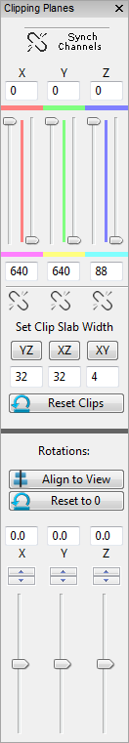When volume property settings become inadequate to reveal occluded structures of thick scans, clipping planes provide an easy solution. For each volume channel, a group of six clipping planes can be adjusted independently. They are +X, -X, +Y, -Y, +Z, and -Z, which are also color-coded as red, magenta, green, yellow, blue, and cyan, for visual distinction.

## Clipping Plane Translations

When the mouse cursor is moved into the clipping plane panel (Figure 10‑1. Clipping plane panel), the clipping planes of selected volume channel are also visualized in the render view. To adjust one clipping plane, first find its color coding from the render view, and then change its position using the corresponding slider. Data outside of the space between two opposite clipping are occluded.

The movement of two opposite clipping planes can be linked, so that moving one will also move the other. To link the movement, click the link button . When the space between two opposite clipping planes is reduced to one (value difference between two clipping planes becomes one), it becomes a visualization of an image section. The section views in Figure 7‑1 are generated using this method. The space between two opposite clipping planes is also called a clip slab, whose width can be set using the controls under link buttons. To set a clip slab width, first input a number into the numeric box, and then click the button above the numeric box. For example, we want to look at an XY image section. An XY image section moves along the Z axis. So, in Figure 10‑1, we look at the numeric box with value “4” under the “XY” button, which is also under the “Z” axis. We change its value to “1”, and then click the “XY” button. +Z and -Z clipping planes are moved and linked. When we change any of +Z and -Z clipping planes, we are browsing through the XY image sections.

|  |  |
| --- | --- |
|  | Alternatively, you can right-click a slider handle to quickly set clip slab width to one. |
|  | You can use keyboard shortcuts to move clip slabs. See Appendices for more details. |

Use the reset button  to reset all clipping plane translations.

Figure ‑. Clipping plane panel.

Clipping plane translations of all channels in one render view can be synchronized. To synchronize the settings, enable “Synch Channels”.

## Clipping Plane Rotations

The group of six clipping planes can be rotated independently of the selected volume channel. There are two methods for clipping plane rotations.

To directly adjust clipping plane rotations, change the rotation values using sliders or numeric boxes.

To rotate clipping planes using render view rotation controls, first rotate the view to an angle, so that the user is looking straight at a desired XY plane. Then, click “Align to View” to rotate clipping planes to align with the intended XY plane. This features is useful when a scan is tilted with an angle.

Use the reset button  to reset all clipping plane rotations.

|  |  |
| --- | --- |
|  | You can save a sub volume defined by the clipping planes using the bake feature. See Chapter 5 for more details. |

# Adjusting Mesh Properties

## Basic Mesh Properties

Mesh objects provide clear boundary information. When a mesh object is selected from the “Workspace” panel, its properties are loaded into the property panel (Figure 11‑1). Change these properties



Figure ‑. Mesh properties.

### Material properties

**Diffuse color.** The base color of the object.

**Specular color.** The color of the object’s highlight.

**Shininess.** The size of the highlight.

### Other properties

**Transparency.** Lower is more transparent. 1 means opaque.

|  |  |
| --- | --- |
|  | Depth peeling is used for rendering transparent mesh objects, as well as rendering with volumes. For higher transparency quality, increase the number of peeling layers in the settings dialog. See Chapter 20 for more details. |

**Shadow.** When enabled, it adds a shadow effect, whose strength can be adjusted with the slider.

**Lighting.** It enables/disables lighting effect. When both shadow and lighting effects are disabled, mesh objects look flat.

**Scaling.** It is a multiplier to the overall scale of a mesh object. Use it to enlarge or shrink a mesh object.

## Mesh Manipulations

Mesh manipulations are enabled from the “Workspace” panel, though context menu. When enabled, the settings are loaded into the “Property” panel (Figure 11‑2).



Figure ‑. Mesh manipulations.

Mesh manipulations allow translate, rotate, scale a mesh object within render view. These settings are changed through numeric input boxes in the user interface.

|  |  |
| --- | --- |
|  | When a mesh object is saved, these manipulation settings are lost. Save a project to save these settings. |

# Movie Playback and Export

This panel enables a user to animate certain aspects of a volume within the rendering view, and is located at the bottom left of the program by default.

The bottom of the panel remains constant for all the tabs. The type of playback depends on which tab is currently visible (Basic vs. Advanced.) If one of the other tabs is in view, the last tab selected determines the playback mode.



Figure ‑. Main movie playback controls.

**FPS.** The frames per second text box allows a user to determine how many frames will be exported per second to either a movie file, or a sequence of TIF files. For example, a movie that is 5 seconds long with 30 FPS will have a total of 150 frames in the movie, or 150 TIF files created. A higher FPS increases the quality and “smoothness” of a movie, but also contributes to a larger file.

**Capture.** This drop-down selection box enables a user to choose which rendering frame to playback on and record to export to file. Having multiple rendering frames is not common, but is sometimes useful for side-by-side comparisons. In most cases, there is only 1 frame to render, and subsequently, only 1 option in this drop-down menu.

 **Help.** This button is a link to open a browser to this reference document.

 **Play.** The “Play” button allows a user to preview what an exported movie will look like

 **Rewind / Reset.** This button returns the playback to the beginning, at time zero, and time frame zero (for a time sequence. If this is pressed during playback or recording, the playback and recording is terminated.

**Time Slider.** This slider indicates where along the movie you are. You can move the slider to any point to visualize a frame at that point in time.

**Time Text.** This text box updates with the slider during playback. You may also edit this to a particular time in the movie (in seconds).

** Save / Export.** This button allows you to export a final movie once you feel the preview playback is adequate.

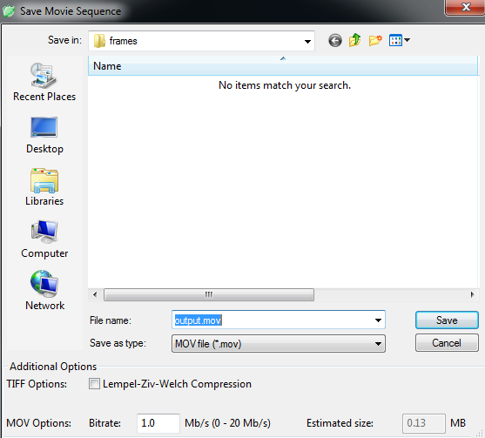

Figure ‑. Save or export a movie or time sequence.

Once you click save, you will see a number of options to export. You can select a location to save the file, as well as a name for the file. If you export TIF files, your filename will be appended with the frame number for each TIF frame. There are two types to save a file as. The default is “MOV”, which is a QuickTime format of movie file. The other option is for a TIF file sequence.

In the additional options, you can select a check for compression (only for TIF sequence output), and bit rate (only for MOV output type). The bitrate determines the quality of the video. Only between approximately 0 and 20 Mb/s (mega bit per second) is supported. The estimated size, based on the Mb/s is on the right. As movies get larger and longer, this estimation becomes less accurate. One Mb/s would approximately be 8 Mb (mega bit) in size if the movie is 8 second long. This would be only about 1 MB (megabyte).

|  |  |
| --- | --- |
|  | In order to successfully compress a MOV file, a movie is required to contain at least 36 frames in total. The total number of movie frames is calculated by multiplying FPS to movie length in seconds. For example, at 30 FPS, a 1 second long movie will be too short to be successfully compressed, since it contains only 30 frames. You can either increase the movie length or export individual frames as TIFF files. |

## Basic Movie Operations

Basic operations include axis-aligned rotations (X, Y, and Z), time frame progression (from a set of volumes organized as subsequent times of the same data), and alternating between a set of differing volumes. Based on the first volume loaded into the program, FluoRender automatically chooses the most common basic playback option in this panel for you.

|  |  |
| --- | --- |
|  | If you load a file that meets the naming convention for a time sequence, the “Batch” feature will be disabled. To use the batch feature, make sure the first volume you load does NOT meet the time sequence convention. The default convention is a “\_T”, followed by a number designating the time of that frame. |

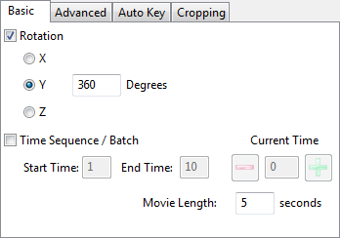

Figure ‑. Basic movie playback controls.

1. Rotations are available axis-aligned in the 3 primary dimensions, X, Y, and Z. The default is Y. When this option is checked, the render view will rotate the volume every frame during playback. The number inside the “Degrees” text box is the number of degrees you wish to rotate for the length of the movie. The number of degrees per frame depends on the length of the movie and the frames per second. For example, if a movie is 5 seconds long, and you are rotating 360 degrees along the Y axis, you will see 72 degrees of rotation in the Y axis when you push the “Play” button.
2. A time sequence is only available if you loaded one of a set of volumes in a directory that meet the time sequence convention. If you have a directory of 100 files, each labelled “image\_T000.tif” through “image\_T099.tif”, for example, you have a valid time sequence when your first volume to load is any 1 of the 100 files. FluoRender will automatically check “Time Sequence / Batch” for you, set the start, end, and current times (based on the # of the file you loaded), and update the movie time slider to where this file is in the sequence.
   1. The  button will take one step backwards in time, loading the previous time volume and updating the time slider and the movie time (right of the slider).
   2. The  button will take one step forward in time. If the next step is after the total number of frames, the time will wrap around to the beginning. The reverse will occur for the minus button.
   3. The start time and end time are set automatically, but you may want to only play back a certain subset of the time frames. For example, out of 100, you may choose to play frames 20-30. FluoRender will correct times that are out of range, including negative numbers.
   4. The movie length is unique to the Basic tab of movie making. You can choose how long (in real seconds) you want the exported movie file to be.

|  |  |
| --- | --- |
|  | Although you select both a movie time in this panel, as well as a FPS (Frame Per Second) for your movie, the playback inside of FluoRender may not preview this in real time. Each frame is rendered during playback as fast as your computer and graphics card can handle. Often, to get the quality of movie you desire, the preview will be much slower than the actual exported file (which WILL honor the time constraints you select). |

* 1. Finally, a batch is a set of several volumes in a directory that may or may not be related. The playback works exactly the same as with a time sequence, but will only have up to the number of frames that matches the number of files in the directory for which your first loaded volume was located. For example, if you have “volumeA.tif”, “volumeB.tif”, and “volumeC.tif”, in a directory, and you load “volumeA.tif”, this playback will alternate between the three files.

## Advanced Key Frame Movies

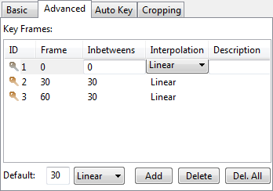

Figure ‑. Advanced movie playback controls.

This tab allows for much more advanced types of movies. Unfortunately, however, time and batch sequences are not available in combination with key frames. Instead, a user manipulates the volume manually in the render view, sets a frame, and repeats as many times as desired. FluoRender then linearly or smoothly interpolates between the several key frames to playback. Because this tab explicitly states the number of frames between each key, there is no option to select movie length (in seconds). Only a FPS is necessary. You can determine the movie time by dividing the total number of frames in the table by the current FPS. For example, if you have 90 frames, and your FPS is 30, the movie will be 3 seconds long.

FluoRender will remember and key frame the following aspects of a volume:

* Rotation transformations
* Translation transformations
* Scale transformations (zoom)
* Cropping (from the Crop panel on the right of the program)
* Enabling and disabling visibility via the “on/off” property in the Workspace panel
* Channel intermixing modes (Layered, Depth, and Composite)

The columns for the key frame table are as follows:

**ID.** This is the ID number of the key. If you choose to, you may reorder keys by dragging and dropping them anywhere in the list. The ID is generated starting at 1 and increases during the runtime of FluoRender. The ID is usually the only way to decipher between the various key frames created, unless you add a “Description” (see below).

**Frame.** This indicates at which frame this particular key is active. You may reset the currently viewed key by double clicking on that key.

**Inbetweens.** This column indicates how many frames exist between this key and the previous key. The first key in the list always has this number as zero.

**Interpolation.** This can be either “Linear”, which means between the keys, frames are exactly 1/#inbetweens steps from one key to the next, or “Smooth”, which means the frames slowly ramp up to the transition, and slowly ramp down to the end of the key frame in an “S-curve” fashion. This can be changed by clicking on the “Linear” or “Smooth”.

**Description.** This is initially empty for each frame. You can click and add your own description for each frame to help you determine which key it is.

Below the table is a list of options.

** Default.** This has a text box and a drop down menu. The text box is the number of default frames to add to each key frame when one is created. This can always be changed per key by selecting the current number on the table. The drop down is again, either “Linear” or “Smooth”. You can select the default, but may also choose what each key uses individually by clicking on the table.

** Add.** Add a new key frame to the list, saving the current rendering transformations, croppings, and channel visibilities.

** Delete.** Delete the selected key frame.

 **Delete All.** Delete all of the key frames in the list.

## Automatic Key Generation

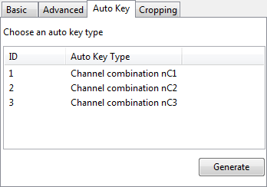

Figure ‑. Auto key options.

This tab allows a user to select an automatic key generation scheme from a list, and then generate key frame animations. You first choose an auto key type, then click “Generate”. Or, you can double-click an option. This brings you to the “Advanced” panel, which contains automatically generated keys. You can then interact with the automatically generated keys using the same controls provided in the “Advanced” panel.

Currently, we provide three options for automatic key generation. More options will be added into the future versions of FluoRender. These three options are:

**Channel Combination nC1.** It sets a key for each isolated channel within a multi-channel data set. You can browse each channel individually with this setting.

**Channel Combination nC2.** It sets a key for each two-channel pair within a multi-channel data set. You can use this function to visualize colocalization regions between any two-channel combination.

**Channel Combination nC3.** Similar to nC2, it sets a key for each triple-channel combination. You can use this setting to visualize all colocalization cases of three channels.

## Frame Cropping



Figure ‑. Frame cropping controls.

This tab allows a user to crop what is captured in the rendering frame to a smaller area. Often, the important data is not covering the whole render view. Recording the whole frame, including a lot of empty space, can be wasteful and make a movie larger than necessary. When enable cropping is selected, you will see a yellow rectangle in the render frame indicating the pixels that will be read and used in the movie file. The yellow rectangle is automatically based on the area that is covered by data. See Figure 3‑1and Figure 3‑2. The “Center X” and “Y” fields allow you to modify where the center of the movie will take place in pixel coordinates. In addition, you can modify the “Size Width” and “Height”. The yellow box will not be in the output, but will remain visible if “Enable Cropping” is selected. The “Reset” button recalculates the cropping region, if you have rotated, zoomed, or panned the view. The cropping square does not resize with the program window as you resize it on your computer, but you can click “Reset” to get the snug cropping region back in the render view.

## Batch Processing (4D Scripts)

A 4D script can be enabled for batch processing a time sequence. The execution of a 4D script is associated with movie play back functions, so that you can simply execute a 4D script by viewing a time sequence. Following these steps to execute a 4D script.

1. Load the time sequence into FluoRender.
2. Enable “4D Script” in the FluoRender settings.
3. Type in or browse to a script file, which should be a text file following one of the specific formats below.
4. The content of the text file decides the type of processing to be executed (see below).
5. Click either “Play” or “Save” to play back the time sequence.
6. The batch processing is executed during sequence play back.

|  |  |
| --- | --- |
|  | Remember to turn off the 4D script setting when you only need playing back a time sequence. |

Currently supported 4D scripts and their detailed formats are follows.

### Noise reduction

It applies noise reduction to each time point and save the result as a new file (List 12‑1). Parameters of a script file include:

**Threshold value** – The threshold for component analysis;

**Voxel size** – The component size to be removed as noise;

**Format** – The file format to be saved;

**Compression** – Whether the file is to be compressed;

**Path name** – A path to saved files. Make sure that the path exists before executing the script.

See Chapter 16 for the meanings of these parameters.

|  |
| --- |
| [tasks]  tasknum=1  [tasks/task0]  type=noise\_reduction  threshold=0.5  voxelsize=500  format=0  compress=0  savepath=./DATA/no\_noise/ |

List ‑. An example 4D script for noise reduction.

### Separate RGB channels

If a time point of a sequence is saved in RGB format, use this script to separate each color channel into a file (List 12‑2). Parameters of a script file include:

**Bake** – Whether volume properties are applied when saving (It can be used to apply volume properties to non-RGB volumes as well);

**Format** – The file format to be saved;

**Compression** – Whether the file is to be compressed;

**Path name** – A path to saved files. Make sure that the path exists before executing the script.

|  |
| --- |
| [tasks]  tasknum=1  [tasks/task0]  type=separate\_channels  bake=0  format=0  compress=1  savepath=./DATA/Channels/ |

List ‑. An example 4D script for RGB channel separation.

### Export components as RGB channels

If component analysis is applied to each time point of a sequence, you can use this script to export components as RGB channels, each component assigned with a color (List 12‑3). Parameters of a script file include:

**Path name** – A path to saved files. Make sure that the path exists before executing the script.

|  |
| --- |
| [tasks]  tasknum=1  [tasks/task0]  type=random\_colors  savepath=./DATA/colored/ |

List ‑. An example 4D script for exporting colored components.

### Tracking

To view automatically tracked results, to correct and proofread automatically tracked results, or to manually track a time sequence, use this script to let FluoRender know that label files are present and IDs need to be linked (List 12‑4). This script does not have parameters.

|  |
| --- |
| [tasks]  tasknum=1  [tasks/task0]  type=selection\_tracking |

List ‑. An example 4D script for tracking.

### Executing an external application

For each time frame of the sequence, an external application is executed. If the application receives arguments, the currently selected volume channel is passed as an argument (List 12‑5). Parameters of a script file include:

**Path name** – A path to the desired application file. Make sure that the file exists before executing the script.

|  |
| --- |
| [tasks]  tasknum=1  [tasks/task0]  type=external\_exe  exepath=./Executables/cl\_synthetic\_brainbows.exe |

List ‑. An example 4D script for executing an external application.

An example executable file is included with the Windows release, in the directory called Executables of the installation. It reads a TIFF file and applies an image processing process called “Synthetic Brainbows” to the data. The results are labeled data for individual structures. You may use this executable file in conjunction with the tracking feature in FluoRender. See Chapter 17 for more details on tracking.

Script examples are included with the FluoRender installation, in the directory called Scripts. You may copy and change the script files to suit your needs.

# Managing Projects

Work in FluoRender can be saved as projects. To save a project, click “Save Project”  in the main toolbar. In the file browser dialog, choose a directory to save a project file (Figure 13‑1).

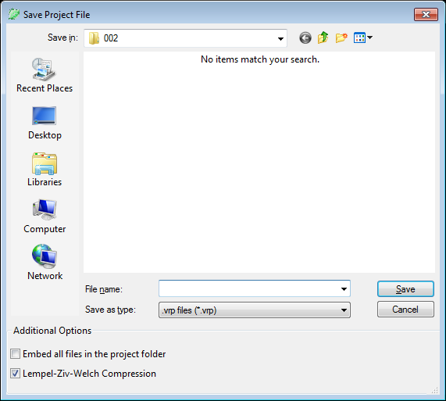

Figure ‑. Save project dialog.

Two options are available when saving a project.

**Embed all files in the project folder.** When checked, FluoRender copies currently opened files and saves them in a folder with the project file. If you choose this option, make sure you copy the folder with the project file.

|  |  |
| --- | --- |
|  | FluoRender does not save data files (volumes, mesh objects, etc.) within a project file. It saves paths instead. If you moved data files or project files, there might be missing links in a project file. When missing links are detected during project loading, FluoRender first searches within the directories containing the project file and looks for files that match the saved names. If missing links cannot be found, the project may not be loaded correctly. You can manually edit a project file using a text editor if this happens. |
|  | Volumes will be saved in TIFF format, disregarding their original formats. |

**Lempel-Ziv-Welch compression.** When enabled, FluoRender uses LZW compression for saving TIFF formats.

Projects can be automatically saved when capturing a render view, or exporting a movie. This setting can be enabled in the setting dialog. See Chapter 20 for more details.

# Paint Selection

FluoRender allows selecting a portion of a volume channel based on underlying structures. Users can directly paint on visualizations in render view and select desired structures. Selected structures become the basis of many subsequent analysis and processing operations. Most paint selection settings are in the “Analyze” dialog. To open the “Analyze” dialog, click “Analyze” 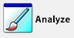 in the main toolbar. The upper part “Selection” of the analyze dialog controls the behavior of paint brushes through a series of settings (Figure 14‑1).

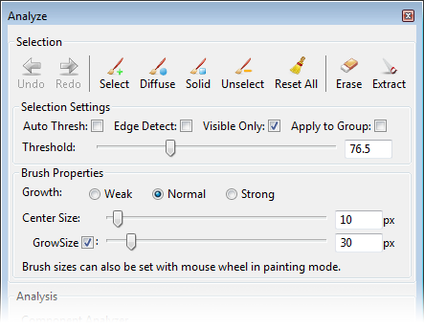

Figure ‑. The selection part of the Analyze dialog.

## Brush Types

There are three brush types. They are accessed by clicking the toolbar buttons in the “Analyze” dialog. When any of the following brush types is selected, user can start painting in render view using a mouse or similar pointing device.

** Select.** When enabled, user can paint on visualizations in render view to initialize selection of desired structures. The brush is typically equipped with two strokes, whose stamps are indicated by two concentric circles. The inner circle, called center stroke stamp, defines seeds for selection. Seeds are selected based on the “Threshold” value in the “Selection Settings”. The outer circle, called diffuse stroke stamp, defines a diffusion region for seeds. Seeds can diffuse or grow within the diffusion region based on a diffusion equation.

** Diffuse.** When enabled, user can paint on visualizations in render view to diffuse or grow existing selected structures. The diffusion brush is exactly a selection brush without the center stamp for seeding. It is used for selecting structures that are three-dimensionally connected to existing selections. It is useful to select complex 3D structures, such as nerves, neuron axons, and dendrites.

 **Solid.** When enabled, user can create masks of fully selected regions disregarding the underlying structures. You can use this brush to create masks even on completely empty regions of the data. It is useful when partial or entire data need to be selected and analyzed without missing any information (including empty space). The solid brush is enabled when the “Shift” key is held down in “Probe”  measurement tool. See Chapter 15 for more details.

** Unselect.** When enabled, user can paint on visualizations in render view and remove selected structures. It behaves like an eraser for masks.

In addition, “Reset All”  can be used to clear all selections.

|  |  |
| --- | --- |
|  | The same set of buttons are found in the “Workspace” toolbar. Alternatively, these keyboard shortcuts can be used: holding “Shift” – Select; holding “z” – Diffuse; holding “x” – unselect. |
|  | Selected structures are indicated by a mask with a different color than original volume channel. The mask color is calculated from the original color and should provide sufficient contrast to be distinguished from the original. For information on assigning IDs and changing mask colors, see the chapter on components and tracking. |
|  | Many settings that changes the visualization of a volume channel can influence the paint selected result. Volume properties take part in the calculation of selected results. For example, voxels out of the threshold value range in the volume proper settings are not selected by the paint brush. One important feature is to use clipping planes to restrict paint selection. For example, when you set the opposite clipping planes in an axis with slab with of one, it essentially allows you to perform paint selection on image sections. |

## Brush History

You can let FluoRender keep a history of the most recent brush strokes, and undo/redo the operations. By default, the history setting is turned off. You need to first choose the number of strokes to be kept in history in the FluoRender Settings (Chapter 20). Once the brush history is turned on, you can use the **Undo**  and **Redo**  buttons to step through the brush stroke history.

|  |  |
| --- | --- |
|  | It consumes more memory and slows down the operations when the brush history is enabled. Disable this feature if you are not working with brushes. |

## Selection Settings

The behavior of bushes can be further refined using the selection settings.

**Auto thresh.** When enabled, it automatically estimates a threshold value for the selection brush. The threshold estimation is calculated based local histogram under a brush stroke. When a stroke is finished, the estimated threshold values is updated.

**Edge detect.** When enabled, it incorporate local contrast information into the diffusion process. When high local high contrast (usually structure boundaries, or edges) is detected, the diffusion stops.

**Visible only.** When enabled, in the seeding process, seeds occluded in 3D are not selected. It is useful to select densely packed structures, such as cells.

**Apply to group.** When enabled, brush strokes are applied to structures from different volume channels within the same group of current selection. It can be used to study colocalized structures within a region defined by brush strokes.

**Threshold.** It is the threshold value for seeding with in the center stroke stamp region. It is also used to determine the strength of the diffusion process. Threshold value can be estimated by enabling the auto threshold function.

|  |  |
| --- | --- |
|  | If auto threshold estimation cannot generate a satisfactory result, user can still change the threshold value manually with the auto threshold option enabled. However, only diffusion brush becomes available for selecting structures. |

## Brush Properties

Brush diffusion strength and stamp sizes are controlled using the following settings.

**Growth.** It provides three strength levels for the diffusion process. It essentially determines how many iterations are used for evaluating the diffusion equation. Stronger means more iterations. When more iterations are used, diffusion tends to grow further, but it may take more time to calculate. Use strong growth strength for coarse selection of large structures. Use weak growth strength for selecting finely-detailed structures.

**Center size.** It is the center stroke stamp size in screen pixels. It determines the region that seed can be chosen by the selection brush.

**Grow size.** It is the outer stroke stamp size in screen pixels. It determines the region that seed can grow. The grow size can also be disabled. When disabled, the selection brush uses the center stroke stamp only. So, the selection brush is for seeding only. The selection will strictly follow the threshold setting. In addition, both the diffusion brush and un-selection brush use the center size for their stamps.

|  |  |
| --- | --- |
|  | When the brush types are enabled, user can use the mouse wheel to adjust the stamp sizes. For the selection brush, the mouse wheel adjusts the grow size only. |

## Creating New Channels from Selection

FluoRender allows creating new channels based on selection. When a structure is selected within a volume channel, two operations are available to create new channels. They are located in the toolbars of the Analyze window and Workspace panel.

**Erase.** It creates a new channel from original volume without the selected structures.

** Extract.** It creates a new channel from original volume with only the selected structures included.

|  |  |
| --- | --- |
|  | You can keep creating new channels using the extract operations. However, the erase operation behaves differently. It creates a new channel and append “\_DELETED” to the end of channel name. If you select some structures from the newly created channel and use the erase operation again, it will operate directly on that channel, without creating a new one. “\_DELETED” is used to identify a channel so that it will not create a new channel for repetitive erase operations. If you do not want this behavior, make sure you change the channel name to one without “\_DELETED”. Additionally, make sure a file name does not include “\_DELETED”, if you do not want to erase directly on the volume channel. |

# Measurement

Measurement functions allow users to create locators and rulers to get position information and measure length. To use the measurement functions, click the downward arrow head on the right side of “Analyze” button in the main toolbar (Figure 15‑1). In the drop down menu, select “Measurement…”.



Figure ‑. Launch Measurement window from main toolbar.

The Measurement window is shown in Figure 15‑2.

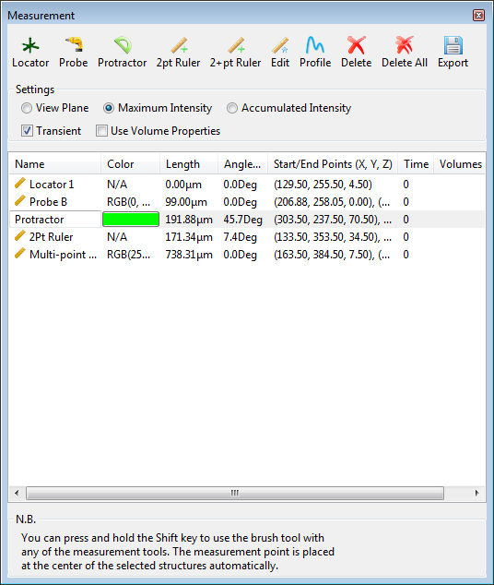

Figure ‑. Measurement window.

## Ruler Types

There are five types of measurement tools you can create.

** Locator.** First click the icon of locator. Then, click in render view to create a locator. A locator is a single point in 3D space, which measures its position in X, Y, and Z coordinates. The newly created locator is added to the list in the measurement window along with its information. The coordinates of the locator is listed under “Start/End Points (X, Y, Z)”. You can keep clicking in render view to create more locators, as long as the toolbar icon is checked.

 **Probe.** Probe tool allows you to create a two-point ruler that goes through the data from the current viewing direction. First find a viewing direction y rotating the view. Then, click once in the render view with the probe tool selected. The newly created probe is added to the list in the measurement window along with its information. The probe tool is mainly used with the paint brush tool and profile tool to generate an averaged intensity profile along the viewing direction. See the profile tool for more details.

 **Protractor.** Protractor allows you to measure the angle between two lines. Click three times in the render view to create an angle measurement. The angle value in degrees is shown in the list of the measurement dialog window.

** Two-point ruler.** First click the icon of two-point ruler. Then, click in render view twice to create the ruler with two end points. The newly created ruler is added to the list in the measurement window along with its information. The length, angle and start/end points can be found in the list as well. You can keep clicking in render view to create more two-point rulers, as long as the toolbar icon is checked.

** Two-plus-point ruler.** First click the icon of two-plus-point ruler. Then, click in render view to create the ruler with multiple points. You can end the ruler by right-clicking. Or, you can uncheck the toolbar icon to end the ruler. The length and start/end points can be found in the list of measurement window. After ending a ruler by right-clicking, you can keep creating more rulers, as long as the toolbar icon is checked.

|  |  |
| --- | --- |
|  | Paint selection brush can be activated when a ruler tool is enabled. It can be used to measure the volume of paint selected structures. To activate paint brush during ruler measurement, you have to use the keyboard shortcut. Hold down the “Shift” key and then paint. A new ruler point is created or appended. The volume of the selection is listed under “Volumes” of the measurement list. The coordinates of a locator or ruler point is the centroid of the selected volume structure. |
|  | Measurement tools disable normal render view interactions. To interact with render view with measurement tools enabled, hold down the “Alt” key and use normal render view interactions, including rotation, zooming, and panning. |

## Profiling

 The profile tool generates an intensity profile within a volume along a selected ruler. First select a ruler from the list in the measurement window, and then click the profile tool. When you export the rulers, the intensity profiles are saved as sequences of numbers in text format. You can read the numbers using an external tool, such as Microsoft Excel. The range of intensity values is 0 to 1, with 1 representing the maximum intensity value of the entire data volume. For most of the ruler types, a number in the intensity profile is sampled from one voxel of the volume data. If the probe tool is used along with a paint brush, which creates a cylindrical mask of the data, the profile tool samples within the masked volume and calculates averaged intensities along a sequence of disk-shape regions along the probe ruler. You can adjust the size of the brush to calculate the averaging in a larger or smaller region.

## Making Changes to Measurement Tools

You can change the position of locators or ruler points after they have been created. In addition, you can change the settings to more easily set the position of locators and ruler points in 3D. These settings and tools are available to make changed to measurement tools.

**Name.** Click a measurement tool in the list. A text edit box shows to allow you change the name of the selected tool. When you type in the text edit box, the name of the selected tool is updated in the render view port at the same time.

**Color.** Click a measurement tool in the list. A color swatch button shows to allow you change the color of the selected tool. Click the color swatch button. It shows a color selector dialog window. Choose the desired color and close the dialog window. A new color is updated to the selected tool in the render view port at the same time.

|  |  |
| --- | --- |
|  | When no color is set for a measurement tool, it uses an automatically calculated color so that it is visible against current background. |

 **Edit.** When enabled, you can click on a locator or ruler point, and change its position by dragging it in render view. Notice that, normal render view interactions are allowed. A locator or ruler point is selected only when you first click within the region indicated by the square box representing the locator or ruler point. Otherwise, you may accidentally rotate the view.

** Delete.** Delete a locator or ruler point currently selected in the measurement list.

** Delete all.** Delete all locators and rulers in the measurement list.

** Export.** Export the measurement list to a file. The file is in text format and can be loaded into a spreadsheet editor such as Microsoft Excel.

### Choosing a depth calculation method

There are three methods you can choose to determine how the 3D position of a locator or ruler point is calculated from screen position. Choose the method based on the underlying volume channel’s structures.

**View plane.** It places a locator or ruler point on the view plane that is perpendicular to the viewing direction, disregarding the under lying volume channel. The depth is fixed when this method is used. Use this method, for example, if you are measuring lengths on an image section.

**Maximum intensity.** It places a locator or ruler point at a depth of a voxel having the maximum intensity along the ray from the viewer. If multiple maximum intensity voxels exist, the closest one is chosen. Use this method, if you want to trace a nerve. However, if the nerve happens to be occluded by other structures at certain locations. The depth may not be calculated as desired. Use the edit tool to correct those points from a different angle of view if necessary.

**Accumulated intensity.** It places a locator or ruler point at a depth of a voxel that all preceding voxels along the ray have an accumulated intensity adequate to occlude it. It usually finds a point on a well-defined structural surface. Use this methods if you want to measure length on a surface. If no such point can be found, it automatically switches to the view plane method.

### Other settings

**Transient.** When enabled, a locator or ruler can only be created and viewed at a specific time point, when a time sequence data set is loaded. The time point that a locator or ruler belong to can be obtained from the measurement list, under “Time”. The setting is ignored when non time sequence data are loaded.

|  |  |
| --- | --- |
|  | This feature can be used to manually track the movement of a certain structure. You can disable transient, choose two-plus-point ruler tool, go to a certain time point of the data, selecting a structure with the paint brush activated, and then proceed to the next time point. Since the transient feature is disabled, you can create a multi-point ruler tool across a series of time point, which represents the trajectory of movement of the selected structure. More sophisticated tracking features are discussed in Chapter 17. |

**Use volume properties.** When enabled, the calculation of the depth value is based on the mapped values after volume properties are applied, include Gamma, threshold, saturation, etc. It allows more precise depth calculation but may take more time to calculate.

# Component Analysis and Calculations

Volume component analysis and calculation functions are found in several separate dialogs, including “Analyze”, “Counting and Volume”, “Noise Reduction”, and “Colocalization Analysis”. While the majority of functions are in the “Analyze” dialog, other dialogs provide convenience to access functions for specific tasks. We first took at the “Analyze” dialog, which can be opened by clicking “Analyze”  in the main toolbar. The component analysis and calculation functions are the bottom part of the dialog (Figure 16‑1).

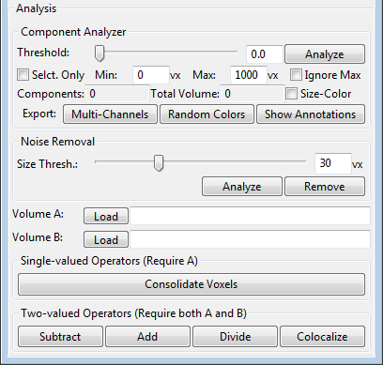

Figure ‑. Component analysis and calculation functions in the Analyze window.

## Component Analysis

The volume component analysis functions are in the “Component Analyzer” section, which are mostly duplicated in the “Counting and Volume” dialog as well. You can use them to analyze the number of components in a volume channel or paint selected structures. Before clicking the “Analyze” button, these settings are available.

### Settings of component analysis

**Threshold.** It sets a threshold on intensity values. Voxels with lower than threshold intensities are excluded from the analysis.

**Selected only.** Only paint selected structures within a volume channel is analyzed. If this option is checked, make sure that you have something selected.

**Min voxel.** The minimum voxel number of a component to be included in the analysis. Use this setting to exclude small size components to be counted, for example, noise data.

**Max voxel.** The maximum voxel number of a component to be included in the analysis. Use this setting to exclude large size components to be counted.

**Ignore Max.** When checked, it ignores the setting of “Max voxel”, so that arbitrarily large components are counted.

**Size-Color.** When checked, the colors of components are mapped to their sizes.

### Component analysis outputs

Two value results are displayed under the component analysis settings, after the analysis is finished.

**Components.** It shows the number of components. For example, if you use it to count the number of cells, it is the number of cells.

**Total volume.** It shows the total number of voxels from all components.

|  |  |
| --- | --- |
|  | More detailed analysis results are stored with annotations. Click “Show annotations” to add annotated results. |

You can also create new channels based on the component results.

**Multi-channels.** It allows you to create a new channel for each component.

|  |  |
| --- | --- |
|  | Make sure that you have enough memory if the number of components is high. It may also take a long time to generate a large number of channels. |

**Random colors.** It allows you to create three channels of red, green, blue. Different components are assigned with randomly generated colors.

|  |  |
| --- | --- |
|  | The setting of “size-color” overrides random color generation. |

**Show annotations.** It adds annotations for each component. When you select an annotation item in the “Workspace” panel, detailed information is loaded into the “Property” panel. You can also export the detailed information as a text file and import it into a spreadsheet editor, such as Microsoft Excel.

|  |  |
| --- | --- |
|  | Save an annotation from the “Dataset” panel. Detailed information includes ID, centroid coordinates, size in voxel, size in physical unit, and averaged intensity. |

## Noise Reduction

Computing of noise reduction is based on component analysis. Components of small size are considered noise and can be removed. Noise reduction can be performed in the “Analyze” window or “Noise Reduction” dialog (Figure 16‑2). To open the “Noise Reduction” dialog, click the downward arrow head on the right side of the “Analyze” button, and choose “Noise Reduction”.

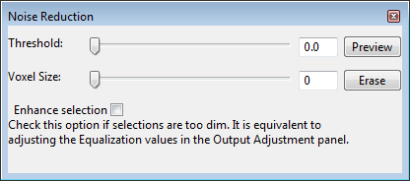

Figure ‑. Noise reduction dialog.

These settings are available in the noise reduction dialog.

**Threshold.** It sets a threshold value to select components. It is the same value in the “Component Analyzer”.

**Voxel size.** It sets the minimum size to select components. It is the same value as “Min voxel” in the “Component Analyzer”.

**Enhance selection.** It highlights the selected noise signals in a different color than the selected volume channel.

Click **“Preview”** to visualize selected noise. Click **“Erase”** to create a new channel of volume with selected noise removed.

|  |  |
| --- | --- |
|  | “Preview” functions the same as “Analyze” button in the component analyzer, and “Erase” functions the same as erase for paint selection. |

## Volume Channel Calculations

Volume calculation functions are located at the bottom of the “Analyze” window. Since up to two channels can be selected and calculated, the volume channels to be calculated have to be loaded into the two slots before calculations.

**Volume A.** To load volume A, select a volume channel from the “Workspace” panel, and then click the “Load” button on right side of “Volume A”. The name of the loaded volume is shown in the slot next to the button.

**Volume B.** To load volume B, select a volume channel from the “Workspace” panel, and then click the “Load” button on right side of “Volume B”. The name of the loaded volume is shown in the slot next to the button.

### Single-valued operations

Single valued operations only requires volume A to be loaded. Only one operation is available.

**Consolidate voxels.** It sets all voxels of the interior of volume A to the maximum intensity (255 for 8-bit data).

|  |  |
| --- | --- |
|  | Consolidating voxels before size calculation may be desired to “fill” holes of original data. |

### Two-valued operations

Four calculations require both volume A and B.

**Subtract.** It subtracts volume B from A, and creates a new volume channel as the result.

**Add.** It adds volume A and B, and creates a new volume channel as the result.

**Divide.** It divides volume A with B, and creates a new volume channel as the result.

**Colocalize.** It creates a new volume channel as the common structures of volume A and B.

## Colocalization Analysis

Colocalization analysis is based on both component analysis and calculations. To open the “Colocalization Analysis” dialog, click the downward arrow head on the right side of the “Analyze” button, and in the dropdown menu, select “Colocalization Analysis” (Figure 16‑3).

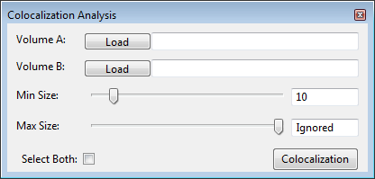

Figure ‑. Colocalization analysis dialog.

Colocalization analysis is performed with two volume channels. Load both channels similar to that for volume calculations. These settings are available to perform colocaliztion analysis.

**Min Size.** It sets the minimum voxel size to count as a component.

**Max Size.** It sets the maximum voxel size to count as a component. The max component size is ignored when the slider is set to the rightmost position.

**Select both.** You can use paint selection to define a sub-region for colocalization analysis. When this option is enabled, you can select both loaded volumes with one brush stroke.

When you click the “Colocalization” button, the common structures between the two loaded channels are first extracted. Then, component analysis is performed on each of volume A, B and common structures. The analyzed results are stored with annotations for each volume.

# Components and Tracking

In Chapter 16, after a volume channel is analyzed, each component is assigned with a unique ID. A time sequence can be labeled similarly for each time point. We provide an external executable file called cl\_synthetic\_brainbows.exe for the Windows installation. It uses a technique called “Synthetic Brainbows” to digitally process a TIFF file and label its structures. You can use this application in conjunction with a 4D script for external application execution. Once the label files are generated, no matter which tool you use, it is possible to automatically track the movements of individual structures using the tools in the Components and Tracking window. The tracking results can then be visualized as trajectories of each linked IDs.

Tracking functions are in the “Component and Tracking” window. To open this window, click the downward arrow head on the right side of the “Analyze” button.

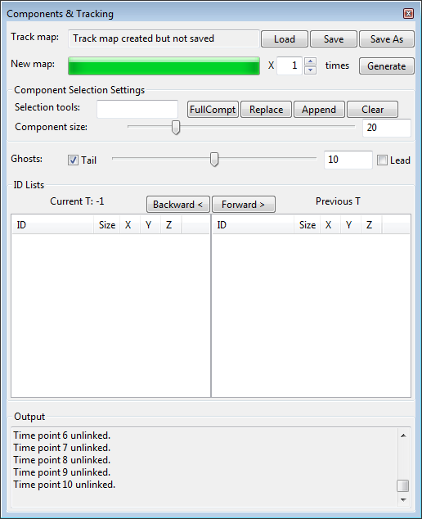

Figure ‑. Components and Tracking window.

|  |  |
| --- | --- |
|  | An ID is a 32-bit unsigned integer to identify a component. In automatic tracking, the same tracked component in different time points may be assigned with different IDs. A tracked structure may be separated into several components in one time point. There is a fixed relationship between ID value of a component and its displayed color. The color is calculated by using (ID mod 360) as the hue. |

## Track Map Generation and Management

A track map describes the linking relationships among components over time. You can generate, load, and save track maps.

Load. Click the load button and browse to a track map file (\*.track) to load it into FluoRender. An unsaved track map generated previously will be deleted.

**Save.** Click the save button to save an existing track map.

**Save As.** Click the save as button to save a modified track map with a different name or directory.

**Generate.** Click the generate button to compute a new track map. You need a time sequence and the time sequence has to be labeled already. Use the included external executable cl\_synthetic\_brainbows.exe (Windows only) with a 4D script to perform the labeling operations.

**Times.** The number of iterations for the track map generation.

|  |  |
| --- | --- |
|  | Since version 2.17, a new format (\*.track) for the tracking results is adopted. The old format (link map, \*.fll) becomes deprecated and unsupported in the new versions. The two formats are also incompatible with each other. Use tracking result files only with the version of FluoRender that generated them. |

## Component Selection Settings

After loading or generating a track map, components can be selected to show the tracking results. The paint brush tools are usually used to select components. You can also fine tune the selection or make precise ID-based selections using these tools.

**ID input box.** You can type in an ID and then select it.

**FullCompt (full component).** A selection made with the paint brush usually does not match exactly with labeled voxels. Click this button after you have made a selection with the paint brush tool and would like to find out the entire component. Make sure to leave the ID input box empty if selecting the entire component is the desired operation. Otherwise it is equivalent to “Append”.

**Replace.** Replace currently selected components with a component with the exact ID in the ID input box.

**Append.** Append a component with the exact ID in the ID input box to the currently selected components.

**Clear.** Clear the selection of all components.

**Component size.** A filter for component selection so that only components of sizes greater than the value are selected.

|  |  |
| --- | --- |
|  | Internally, a 4D script is executed to find out and highlight tracking results. You need to enable 4D script and choose the correct script file in order to use the tracking features. See Chapter 12 and Chapter 20 for more details. |

## Ghost Settings

**Ghosts.** Ghosts are line segments before and after a tracked component to indicate its movement. Ghosts indicating the movement ahead of time are called **leads**; Ghosts indicating the past movement are called **tails**. You can control the visibility of leads and tails individually by checking their names before and after the ghost number slider. The ghost number slider is controlling the number of ghosts, or line segments can be displayed. Although the range of the slider is [0, 20], you can type in an arbitrarily larger number in the numeric input box.

|  |  |
| --- | --- |
|  | You need to select a component and add it to the ID list below to view its ghosts. |



**Tails**

**Leads**

Figure ‑. Ghosts of a tracked cell.

## ID Lists

There are two lists for current and previous time points. Time point values are shown on top of both lists. When the time point is set forward by one, the current time point value is that of the previous plus one; when the time point is set backward by one, the current time point value is that of the previous minus one. When time point changes, IDs on the current time point list are copied to the previous time point list, and current time point list is updated.

|  |  |
| --- | --- |
|  | You can copy a selected ID using shortcuts provided by your operating system. |

## Output

Information is shown in the output box.

# Volume-Mesh Conversion

You can extract iso-surfaces from a volume channel or its selected part, and create a new mesh object. The settings of volume-mesh conversion are in the “Convert” dialog. To open convert dialog, click the downward arrow head on the right side of the “Analyze” button, and in the dropdown menu select “convert”.

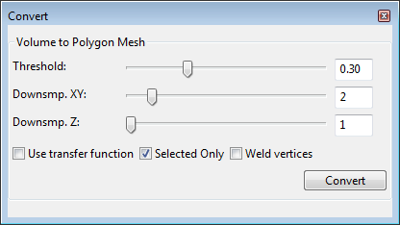

Figure ‑. Convert dialog.

You can select a volume channel and click “Convert” to generate a new object. Additionally, you can first select part of a volume channel using the paint brush, and then convert only the selected part. Before you click the convert button, several settings are available to adjust the conversion.

**Threshold.** The iso-value for mesh calculation.

|  |  |
| --- | --- |
|  | Marching-cubes algorithm is used to calculate the iso-surface. |

**Down sample XY.** It increases the grid size on the XY plane to the setting value. The generated mesh object becomes coarse as the value increases.

**Down sample Z.** It increases the grid size in on the Z axis. The generated mesh object becomes coarse as the value increases.

**Use transfer function.** When enabled, the iso-surface calculation takes volume properties into consideration. For example, no mesh is generated for voxels with intensity below the threshold setting in the volume properties.

**Selected only.** Only the paint selected part of a volume channel is used to generate the mesh object. Make sure you have something selected if this option is enabled.

**Weld vertices.** It merges overlapping vertices so that a smooth shading can be applied.

# Contributing to FluoRender

You can contribute to FluoRender by adding new functions to its source code, or writing data processing modules with FluoRender’s built-in OpenCL kernel editor.

## Developing and Contributing with Source Code via GitHub

FluoRender is “Open Source”, and is hosted on GitHub publicly. Anyone can clone or download the repository to access the source code and build it for their own machine. You are expected to learn and understand “git” if you wish to contribute to FluoRender. FluoRender is accessible with the terms of the MIT license agreement.

You may view the GitHub page for FluoRender for full and detailed clone and build instructions:

<https://github.com/SCIInstitute/fluorender>

The build instructions can change frequently, so duplicating them in this document is not feasible.

A simple SSH clone of the repository is done in the command line (assuming you have GIT installed) with the following line:

|  |
| --- |
| git clone git@github.com:SCIInstitute/fluorender.git |

You can then fork your own branch to make changes and improvements.

If you wish to merge your improvements into the master branch, or another branch, please request a “Merge Request” via GitHub, or on the command line.

You may also report bugs and suggest feature requests on GitHub.

## OpenCL Kernel Editor

To open the OpenCL kernel editor, click the downward arrow head on the right side of the “Analyze” button, and in the drop down menu select “OpenCL Kernel Editor” (Figure 19‑1). You can load an OpenCL kernel file and apply it to currently selected volume channel. Or, you can write your own kernel code with the built-in editor.

|  |  |
| --- | --- |
|  | OpenCL 1.1 is currently supported. |

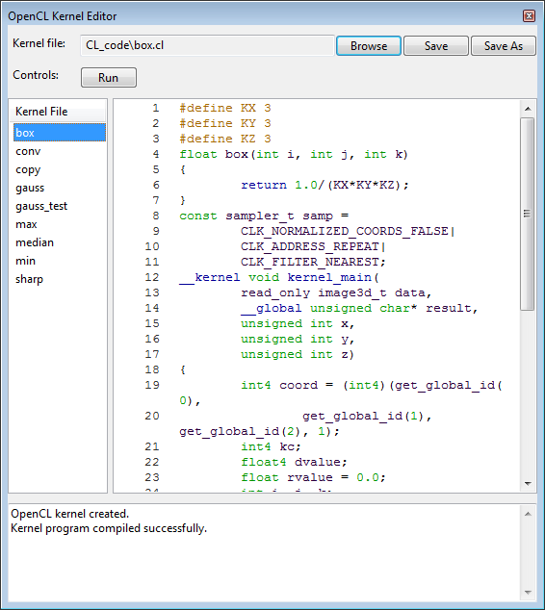

Figure ‑. OpenCL kernel editor.

### Open and save kernel files

To open a kernel file, click “Browse”, and in the file browser dialog, choose a kernel file. To save an already opened kernel file, click “save”, and the content of the original file will be overwritten. To save a modified kernel file with a different name or path, click “save as”, and in the file browser dialog, choose a directory and file name to save it.

### Built-in kernel files

Built-in kernel files can be found in the CL\_code folder. Any file in this folder is listed on the left side of the OpenCL kernel editor window. To load a built-in kernel file, click the kernel file name. Then, the kernel code is loaded to the code panel in the editor.

### Code panel

Write your own code or modify built-in code for more data processing functions. Coding should strictly follow the OpenCL 1.1 standard ([www.khronos.org/opencl/](http://www.khronos.org/opencl/)). In addition, pay attention to the following requirements.

1. Kernel entry point should be named with kernel\_main.
2. Currently selected volume channel is read by the kernel as an OpenGL 3D texture. The first parameter of type image\_3d is used.
3. Resulting volume channel has type unsigned char\*, its resolution is specified by the subsequent parameters, which are of unsigned int type.

|  |  |
| --- | --- |
|  | The current design of OpenCL interface allows one input volume and one output volume of exactly the same resolution. A kernel can have access to all sample point of both volumes. Please contact us for suggestions on more interface types. |

### Run a kernel

Click “Run” to execute a kernel on currently selected volume channel. A new channel of calculation result is created if the kernel is successfully compiled. The new channel is named after the original channel with “\_CL” appended to the end. If you apply a kernel to a channel with “\_CL” tag in its name, no new channel is created and the kernel’s processing is directly applied to it. This allows you to repeatedly apply a kernel to a channel.

### Output panel

Kernel compiling information is listed in the output panel. If a kernel fails to compile, error messages can be found in the output panel. Correct your kernel code based on the error messages if this happens.

# Settings

FluoRender’s settings are found in the “Settings” dialog. To open setting dialog, click “Settings”  in the main toolbar. The setting dialog groups settings into four panels for project, rendering, performance, and file formats.

|  |  |
| --- | --- |
|  | FluoRender’s settings are saved in text format with fluorender.set. You can use a text editor to modify settings directly. |

## Project Settings

Project settings are in the project panel. (Figure 20‑1)

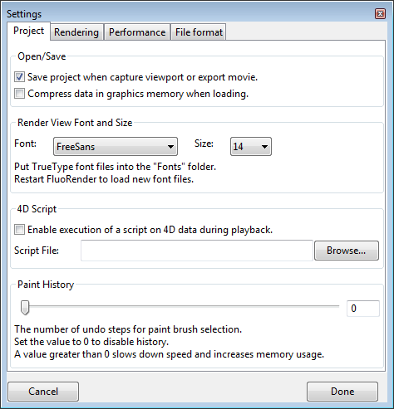

Figure ‑. Settings, project panel.

### Open/Save

**Save project when capture viewport or export movie.** When enabled, it automatically saves a project file when you click the “capture” button in render view, or export a movie.

**Compress data in graphics memory when loading.** When enabled, it uses OpenGL texture compression to save graphics memory.

|  |  |
| --- | --- |
|  | Depending on your graphics hardware, textures may not be correctly compressed. Disable this option if this happens. |

### Font

**Font.** FluoRender searches and lists all True-type font files in the /Fonts folder within its installation directory. Choose the desired font so that it is used for render view text.

|  |  |
| --- | --- |
|  | If you want to display Unicode characters in the render view port, you have to copy a True-type font file that supports the character sets into the /Fonts folder. Then, restart FluoRender so that the font list can be regenerated. |

**Size.** Change the font size for render view text.

### 4D Script

**Enable execution of a script on 4D data during playback.** When enabled, a script describing a data processing can be executed when a 4D sequence is played. See Chapter 12 for more details.

**Script File.** Choose a script file to be executed when a 4D sequence is played. Remember to change the setting if you want to execute a file for a different task. Example scripts are included in the Script directory of FluoRender’s installation.

### Paint History

Paint history is the number of paint brush operations that can be remembered by FluoRender. Set a number greater than 0 to use the **Undo** and **Redo** features in the Analyze window. The paint history is kept for each volume independently. Make sure that you choose a reasonable number so that memory consumption remains low.

## Rendering Settings

Rendering settings are in the rendering panel (Figure 20‑2).

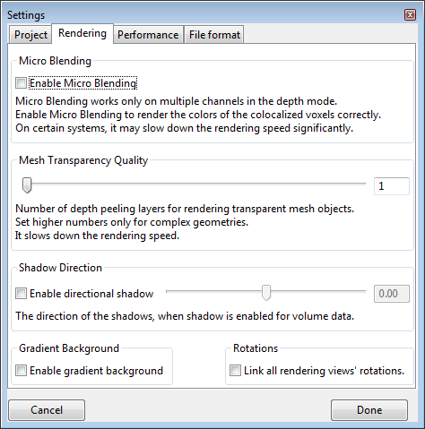

Figure ‑. Settings, rendering panel.

### Micro Blending

**Enable micro blending.** When enabled, channel intermixing in depth mode has more accurate results.

### Mesh transparency quality

It sets the number of depth peeling layers for rendering semi-transparent mesh objects, and for mixing mesh objects with volumes. Higher number is for better quality when mesh objects have complex shapes.

### Shadow direction

**Enable directional shadow.** When enabled, shadows are casted at an angle to the viewing direction.

**Shadow direction.** Use the slider to set shadow direction when directional shadow is enabled.

### Gradient background

**Enable gradient background.** Use a gradient background with a faded horizon, instead of a solid color set in render view.

### Rotations

**Link all render view rotations.** When enabled, rotations of multiple render views are synchronized. You can view all render views from the same angle.

## Performance Settings

Performance settings are in the performance panel (Figure 20‑3).

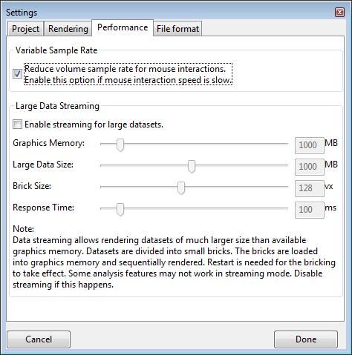

Figure ‑. Settings, performance panel.

### Variable sample rate

**Reduce volume sample rate for mouse interactions.** When enabled, a lower sample rate is used during mouse interactions. It allows better interaction speed, but rendering may flicker.

### Large data streaming

**Enable streaming for large data sets.** Enable this option if data sets to be visualized are too large to load into graphics hardware or too slow to render.

**Graphics memory.** Set this setting to the size of your graphics memory. Check hardware information on graphics cards. Data larger than this size are streamed from system memory to graphics memory.

**Large data size.** It is a limit that larger data sets are broken into bricks.

**Brick size.** When a data set is larger than the limit set by **large data size**, it is broken into bricks with a size of this setting for each of X, Y, and Z axes.

**Response time.** It is a time limit between two updates during data streaming. Shorter time makes rendering more responsive to user interactions, but less content of a data set may be processed and rendered.

## File Format Settings

File format settings are in the file format panel (Figure 20‑4).

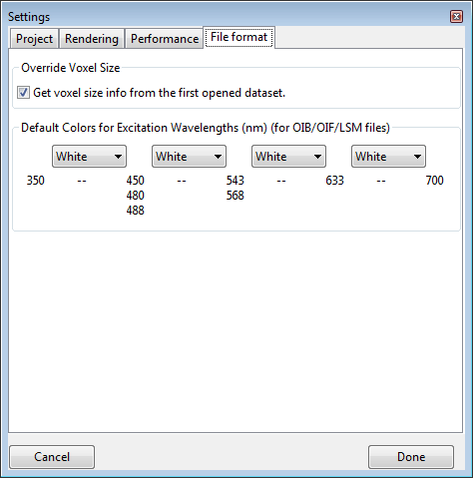

Figure ‑. Settings, file format panel.

### Override voxel size

**Get voxel size info from the first opened data set.** When multiple data sets are opened and they have different voxel sizes, you can enable this option so that all use the voxel size from the first opened file. If this option is not enabled, you can still set all data sets to use the same voxel size by typing voxel spacing values in one data set’s volume property panel (see Chapter 8 for more details).

**Default colors for excitation wavelengths.** You can set different default colors for four excitation wavelength intervals. If metadata are read from a microscopy format and its excitation wavelength falls into one of the intervals, a predefined color is used. You can still change the color of a volume channel once it is loaded.

|  |  |
| --- | --- |
|  | For Olympus formats, if a channel is lit by transmitted light, the default color is always set to white. |

## Settings through the “fluorender.set” File

Some advanced and experimental settings of FluoRender are not exposed in the user interface. You have to modify these settings in the “fluorender.set” file. The “fluorender.set” is a text file that can be edited by any text file editor, such as WordPad or TextEdit. Settings are grouped under entries, whose names are in brackets. An entry can have multiple values. You need to locate a value under an entry, and then change the value behind the equal sign. Depending on the operating system, you may need the administrator privilege to make modifications to the file.

### Ten-bit output

Change the values under [pixel format] to modify the color bits.

To enable 10-bit output, use these settings:

|  |
| --- |
| [pixel\ format]  red\_bit=10  green\_bit=10  blue\_bit=10  alpha\_bit=2  depth\_bit=24 |

List ‑. Pixel format settings for 10-bit output.

|  |  |
| --- | --- |
|  | You will need the latest professional graphics card (AMD FirePro or Nvidia Quadro) and a 10-bit capable LCD display to use this feature. This feature is also Windows only. Ten-bit signals are not supported by Thunderbolt or HDMI connections. You have to use DisplayPort to enable this feature. |

The default settings are:

|  |
| --- |
| [pixel\ format]  red\_bit=8  green\_bit=8  blue\_bit=8  alpha\_bit=8  depth\_bit=24 |

List ‑. Pixel format settings for standard output.

### Antialiasing

Change the value of “samples” under [pixel format] for antialiasing settings. The setting of 0 disables antialiasing. Setting of a higher number can smooth jagged edges and lines of the rendering.

|  |
| --- |
| [pixel\ format]  samples=4 |

List ‑. Pixel format settings for antialiasing.

|  |  |
| --- | --- |
|  | The actually supported sample number varies depending on your graphics hardware. Set it to 0 if antialiasing is not supported by your graphics card, or rendering becomes too slow. |

### Selection of OpenCL GPUs

Change the value of “device\_id” under [cl device] to select a different GPU for OpenCL calculations. The installed and activated GPUs are numbered starting from 0. Make sure that the selected GPU ID is within the valid range.

|  |
| --- |
| [cl\ device]  device\_id=0 |

List ‑. Pixel format settings for antialiasing.

### Selection of OpenGL core profile version and GLSL version

Change the values “gl\_major\_ver” and “gl\_minor\_ver” under [context attrib] to set the OpenGL core profile version and GLSL version. Make sure that a valid version for your system is selected.

|  |
| --- |
| [context\ attrib]  gl\_major\_ver=4  gl\_minor\_ver=5 |

List ‑. Pixel format settings for antialiasing.

|  |  |
| --- | --- |
|  | For some graphics cards, anti-aliasing becomes unavailable under certain OpenGL versions. Straight lines become jagged with anti-aliasing. Change the OpenGL version to see if anti-aliasing is enabled. |

### Soft threshold

Change this value so that threshold settings of a volume use a value range to transit from low to high values. This can give the edges a soft look. This feature is turned off by setting the value to 0.

|  |
| --- |
| [soft\ threshold]  value=0.1 |

List ‑. Pixel format settings for antialiasing.

### Test mode

Change the values under test mode to enable or disable certain test features. Set a value to 1 to enable; set a value to 0 to diable.

|  |
| --- |
| [test\ mode]  speed=0  param=0  wiref=0 |

List ‑. Pixel format settings for antialiasing.

The test modes are:

**Speed.** Continuously refreshing the render view even without user interactions. The FPS reading tells you the speed of your computer hardware.

**Param.** Displaying more parameter information.

**Wiref.** Showing volume bounding boxes and slices in wireframe mode.

# Appendices

## A. Functions of FluoRender

### List of functions of FluoRender on Windows and Mac OS X

| Functions | Windows | Mac OS X |
| --- | --- | --- |
| **Basic visualization** | **●** | **●** |
| View rotation | **●** | **●** |
| Geared rotation of 45º | **●** | **●** |
| View panning | **●** | **●** |
| Center data/panning reset | **●** | **●** |
| View zooming | **●** | **●** |
| 1:1 zoom ratio setting | **●** | **●** |
| Depth attenuation | **●** | **●** |
| Screen capture | **●** | **●** |
| View center axis | **●** | **●** |
| View information display | **●** | **●** |
| Legend display | **●** | **●** |
| Scale bar display | **●** | **●** |
| Perspective angle adjustment | **●** | **●** |
| Free fly | **●** | **●** |
| Background color setting | **●** | **●** |
| Gradient background | **●** | **●** |
| Render view font | **●** | **●** |
| Create new render view | **●** | **●** |
| Link render view rotations | **●** | **●** |
| Render view setting save | **●** | **●** |
| **Multi-channel support** | **●** | **●** |
| Layered channel intermixing mode | **●** | **●** |
| Depth channel intermixing mode | **●** | **●** |
| Micro blending in depth mode | **●** | **●** |
| Composite channel intermixing mode | **●** | **●** |
| Channel grouping | **●** | **●** |
| Synchronize group settings | **●** | **●** |
| Depth mode for group | **●** | **●** |
| Channel streaming | **●** | **●** |
| **Large data streaming** | **●** | **●** |
| Graphics memory setting | **●** | **●** |
| Large data size setting | **●** | **●** |
| Brick size setting | **●** | **●** |
| Response time setting | **●** | **●** |
| **Format support** | **●** | **●** |
| TIFF, including stack and time sequence | **●** | **●** |
| Big TIFF | **●** | **●** |
| OIB, Olympus image binary | **●** | **●** |
| OIF, Olympus original imaging | **●** | **●** |
| LSM, Zeiss laser scanning microscope | **●** | **●** |
| XML, Prairie view | **●** | **●** |
| Metadata interpretation for microscopy | **●** | **●** |
| Nrrd, Near raw raster data | **●** | **●** |
| OBJ, Wavefront object | **●** | **●** |
| VRP, FluoRender project | **●** | **●** |
| DFT, FluoRender defaults | **●** | **●** |
| SET, FluoRender settings | **●** | **●** |
| MSK, FluoRender mask | **●** | **●** |
| LBL, FluoRender label | **●** | **●** |
| CL, OpenCL kernel | **●** | **●** |
| S3 texture compression | **●** | **●** |
| TRACK, FluoRender track map | **●** | **●** |
| **Volume operations and settings** | **●** | **●** |
| Click selection | **●** | **●** |
| DVR, direct volume rendering | **●** | **●** |
| MIP, maximum intensity projection | **●** | **●** |
| Trilinear Interpolation | **●** | **●** |
| Smoothing | **●** | **●** |
| Add to legend | **●** | **●** |
| Voxel spacing | **●** | **●** |
| Primary color | **●** | **●** |
| Secondary color | **●** | **●** |
| Gamma | **●** | **●** |
| Extract boundary | **●** | **●** |
| Saturation | **●** | **●** |
| Low and high thresholds | **●** | **●** |
| Luminance | **●** | **●** |
| Light | **●** | **●** |
| Shadow, can be disabled | **●** | **●** |
| Directional shadow | **●** | **●** |
| Alpha, can be disabled | **●** | **●** |
| Sample rate | **●** | **●** |
| Shading, can be disabled | **●** | **●** |
| Color map, can be disabled | **●** | **●** |
| Color map type | **●** | **●** |
| Color map mapping mode | **●** | **●** |
| Default setting save/restore | **●** | **●** |
| **Volume clipping planes** | **●** | **●** |
| Axis-aligned clipping | **●** | **●** |
| Synchronize positive and negative planes | **●** | **●** |
| Clip slab width | **●** | **●** |
| Clipping plane rotation | **●** | **●** |
| View-aligned rotation | **●** | **●** |
| Resetting | **●** | **●** |
| Synchronize channels | **●** | **●** |
| Visualizing clipping planes | **●** | **●** |
| **Output adjustment** | **●** | **●** |
| RGB independent adjustment | **●** | **●** |
| Automatic RGB channel synchronization | **●** | **●** |
| Gamma | **●** | **●** |
| Luminance | **●** | **●** |
| Equalization | **●** | **●** |
| Default setting save/restore | **●** | **●** |
| Independent settings for render view | **●** | **●** |
| **Mesh operations and settings** | **●** | **●** |
| Click selection | **●** | **●** |
| Wireframe | **●** | **●** |
| Diffuse color | **●** | **●** |
| Specular color | **●** | **●** |
| Shininess | **●** | **●** |
| Transparency | **●** | **●** |
| Shadow, can be disabled | **●** | **●** |
| Lighting, can be disabled | **●** | **●** |
| Line size limit (for lines only) | **●** | **●** |
| Translation | **●** | **●** |
| Rotation | **●** | **●** |
| Scaling | **●** | **●** |
| Transparency quality (depth peeling) | **●** | **●** |
| **Data set view operations** | **●** | **●** |
| Add selection to view (data duplication) | **●** | **●** |
| Rename selection | **●** | **●** |
| Save selection | **●** | **●** |
| Bake (save selection with settings applied) | **●** | **●** |
| Delete selection | **●** | **●** |
| Delete all | **●** | **●** |
| **Workspace operations** | **●** | **●** |
| Visibility toggle | **●** | **●** |
| Create group for volume data | **●** | **●** |
| Create group for mesh data | **●** | **●** |
| Ordering through drag-n-drop | **●** | **●** |
| Delete selection | **●** | **●** |
| Isolation | **●** | **●** |
| Show all | **●** | **●** |
| Randomize color | **●** | **●** |
| **Record/Export operations** | **●** | **●** |
| Axis-aligned rotations | **●** | **●** |
| Time sequence playback | **●** | **●** |
| File batch playback | **●** | **●** |
| Time control | **●** | **●** |
| View selection | **●** | **●** |
| Key frame animation | **●** | **●** |
| Key frame interpolation (linear/smooth) | **●** | **●** |
| Automatic key generation | **●** | **●** |
| View cropping | **●** | **●** |
| **Movie export formats** | **●** | **●** |
| TIFF, LZW compression selectable | **●** | **●** |
| MOV, bit rate selectable | **●** | **●** |
| **Paint selection** | **●** | **●** |
| Selection brush | **●** | **●** |
| Diffusion brush | **●** | **●** |
| Solid brush | **●** | **●** |
| Unselecting brush | **●** | **●** |
| Reset selection | **●** | **●** |
| Erase | **●** | **●** |
| Extract | **●** | **●** |
| Threshold setting | **●** | **●** |
| Auto threshold estimation | **●** | **●** |
| Edge detection | **●** | **●** |
| Visible-only selection | **●** | **●** |
| Select multi-channel volumes in group | **●** | **●** |
| Growth strength | **●** | **●** |
| Brush size adjustment | **●** | **●** |
| Paint history | **●** | **●** |
| **Measurement** | **●** | **●** |
| Locator | **●** | **●** |
| Probe | **●** | **●** |
| Protractor | **●** | **●** |
| 2 point ruler | **●** | **●** |
| 2+ point ruler | **●** | **●** |
| Ruler point editing | **●** | **●** |
| Profile | **●** | **●** |
| Delete selection | **●** | **●** |
| Delete all | **●** | **●** |
| Export ruler information | **●** | **●** |
| Setting ruler point on view plane | **●** | **●** |
| Setting ruler point at maximum intensity | **●** | **●** |
| Setting ruler point at accumulated intensity | **●** | **●** |
| Time-dependent ruler (transient) | **●** | **●** |
| Use volume properties for calculation | **●** | **●** |
| Paint brush selection in ruler mode | **●** | **●** |
| Measure location | **●** | **●** |
| Measure length | **●** | **●** |
| Measure angle (2 point ruler only) | **●** | **●** |
| Measure volume (when paint selected) | **●** | **●** |
| Configurable text | **●** | **●** |
| Configurable color | **●** | **●** |
| **Processing and analysis** | **●** | **●** |
| Component counting | **●** | **●** |
| Component size | **●** | **●** |
| Component export | **●** | **●** |
| Component annotation | **●** | **●** |
| Track map generation (automatic tracking) | **●** | **●** |
| Track map loading | **●** | **●** |
| Track map saving | **●** | **●** |
| Track map visualization | **●** | **●** |
| Component selection by ID | **●** | **●** |
| Noise removal | **●** | **●** |
| Voxel consolidation | **●** | **●** |
| Volume subtraction | **●** | **●** |
| Volume summation | **●** | **●** |
| Volume division | **●** | **●** |
| Volume colocalization | **●** | **●** |
| Volume-mesh conversion | **●** | **●** |
| **OpenCL filtering** | **●** | **●** |
| Box filter | **●** | **●** |
| Gaussian filter | **●** | **●** |
| Convolution | **●** | **●** |
| Median filter | **●** | **●** |
| Morphological erosion | **●** | **●** |
| Morphological dilation | **●** | **●** |
| Feature sharpening | **●** | **●** |
| **Batch processing (4D script)** | **●** | **●** |
| Noise reduction | **●** | **●** |
| Separate RGB channels | **●** | **●** |
| Export components as RGB channels | **●** | **●** |
| Selection tracking | **●** | **●** |
| External application execution | **●** | **●** |
| **Project** | **●** | **●** |
| Loading project | **●** | **●** |
| Saving project | **●** | **●** |
| Automatic project saving when capture | **●** | **●** |
| **Miscellaneous** | **●** | **○** |
| 10-bit output (requires GPU support) | **●** |  |
| Antialiasing (requires GPU support) | **●** | **●** |
| Selection of OpenCL GPU (requires multiple GPUs) | **●** | **●** |
| Selection of OpenGL core profile version | **●** | **●** |

 = New or improvements in FluoRender 2.17

 = New or improvements for Mac OS X

## 

## B. File Formats

FluoRender supports a series of file formats to load and save data. This is a list of all supported formats.

### Tagged Image File Format (TIFF)

The implementation of TIFF format is based on TIFF specification revision 6.0 of June, 1992. Features of TIFF format that are supported in FluoRender include:

System-dependent bit order;

Grayscale and RGB data;

Image stacks;

BYTE and SHORT data;

LZW compression;

Data strips;

In addition, Big-TIFF specification is also supported.

### Near Raw Raster Data (NRRD)

Nrrd reading and writing is based on Teem tools. FluoRender supports reading and writing single channel byte and short nrrd formats.

### Olympus Microscopy (OIB and OIF)

Our implementation is based on OIB/OIF format specification version 1.0.0.0.

### Zeiss Laser Scanning Microscopy (LSM)

Our implementation is based on LSM 5/7 release 6.0 of January 2011. Larger-than-4GB data are supported.

### Prairie View (XML)

Prairie View version 5.1 and older are supported. Our implementation of the Prairie View format is supported by developers from Bruker Corporation.

## C. Keyboard Shortcuts

### For render view

**F5.** Refresh render view.

**Ctrl+Left.** Pan left for one entire view.

**Ctrl+Right.** Pan right for one entire view.

**Ctrl+Up.** Pan up for one entire view.

**Ctrl+Down.** Pan down for one entire view.

### For color input in volume property settings

**B.** Blue (0, 0, 255)

**C.** Cyan (0, 255, 255)

**G.** Green (0, 255, 0)

**K.** Black (0, 0, 0)

**M.** Magenta (255, 0, 255)

**R.** Red (255, 0, 0)

**W**. White (255, 255, 255)

**Y.** Yellow (255, 255, 0)

### For paint brush tool

**Shift (Hold).** Enable selection brush.

**Z (Hold).** Enable diffusion brush.

**X (Hold).** Enable eraser.

**V (Hold).** Disable highlighting.

### For moving clipping plane slab

**W.** Move up one slab.

**S.** Move down one slab.

### For stepping through a time sequence

**A.** Step backward one time point.

**D.** Step forward one time point.

# Index

A

Alpha 31

B

Bake 22, 46

C

Channels 17, 28, 29, 35, 46, 52, 59, 60

Clipping plane 36

Colocalized 29, 45, 52

Component analysis 58

Composite mode 29

Cropping 43, 45

D

Depth attenuation 30

Depth mode 29, 34

E

Equalization 35

F

FPS 40, 43

G

Gamma 31, 35

Ghost 65

I

Install 9

Interpolation 33, 44

L

Layered mode 29, 34

Leads 65

Legend 30, 34

M

Measurement 24, 54

MIP 33

N

Noise 22, 34, 46, 58, 60

Noise reduction 46, 60

O

OpenGL 69, 71

P

Perspective 28

Probe 55

Profile 56

Project 48

S

Sample rate 33

Select 28, 50, 52, 58, 61

Sequence 18, 19, 40, 45, 57, 63

Settings 26, 29, 34, 35, 50, 51, 57, 71

Shading 33

Shadow 33, 38, 73

Streaming 19, 74

T

Tails 65

Threshold 32, 46, 51, 52, 58, 60